# This installation is little differ in compare with similar, that was before.
# Here had register servers in RHN sequently. I did it to receive repository files.

# I’ve configured these servers to use vlan, but network admins gave not tagged access.
# That’s because of servers booted, I change thir network configuration to use network without vlans.

http://servicedesk/fx/sd/ru.naumen.sd.published_jsp?uuid=svcall1bc2gv00000l9n7dq33p0qc618

................................................................................
................................................................................

M1
v323-8

https://racktables.tcsbank.ru/index.php?page=object&object_id=2327
CV27RG2
idrac: 10.219.9.156
10.216.41.73
m1-splunk-nidx01

https://racktables.tcsbank.ru/index.php?page=object&object_id=2329
CV77RG2
idrac: 10.219.9.158
10.216.41.74
m1-splunk-nidx02

https://racktables.tcsbank.ru/index.php?page=object&object_id=2326
CVC5RG2
idrac: 10.219.9.155
10.216.41.75
m1-splunk-nidx03

https://racktables.tcsbank.ru/index.php?page=object&object_id=2328
CVCBRG2
idrac: 10.219.9.157
10.216.41.76
m1-splunk-nidx04

DS
E02

https://racktables.tcsbank.ru/index.php?page=object&object_id=2310
CV39RG2
idrac: 10.219.11.135
10.216.42.73
ds-splunk-nidx01

https://racktables.tcsbank.ru/index.php?page=object&object_id=2309
CV48RG2
idrac: 10.219.11.136
10.216.42.74
ds-splunk-nidx02

https://racktables.tcsbank.ru/index.php?page=object&object_id=2312
CV89RG2
idrac: 10.219.11.133
10.216.42.75
ds-splunk-nidx03

https://racktables.tcsbank.ru/index.php?page=object&object_id=2311
CVB6RG2
idrac: 10.219.11.134
10.216.42.76
ds-splunk-nidx04

................................................................................
................................................................................

# 1. Create access from Dell OME server to these servers (tuffin and network admis).
# 2. In Dell OME find and discovery servers.
# 2.1. Update firmware on servers.
# 2.2. Apply common configuration for iDRAC (access via domain authorization).
# 2.3. Change root password for iDRAC.
# 2.4. Create raid array configuration.
# 3. Find free ip-addresses via vm-pinger and fix it for defined serves.
# 3.1. Create task to write DNS names for A and PTR zones for choosen ip-addresses.
# 4. Create Service Desk task for network admins to configure switch for appropriate ports and give vlan's.
# 5. Run deployment tool "F10" and start manual installation.
# 6. Login on installed server with its console as root and test and add network configs.
# 7. Login on serves via ssh and disable firewald.
# 8. Add repositories. Configure it to work.
# 9. Install puppet.
# 10. Add servers into puppet. Apply manifests.
# 11. Create users, that will use this server (lzn and other).
# 12. Install software for monitoring (idrac and so on).
# 13. Nagios monitoring configure.
# 14. Update information in racktables about servers.

................................................................................
................................................................................

#
# After installation I’ve found follow kickstart file.
# Probably it would be used in future for unatteded installation.
#

[root@ds-splunk-nidx01 ~]# cat ~/anaconda-ks.cfg
#version=DEVEL
# System authorization information
auth --enableshadow --passalgo=sha512
repo --name="Server-HighAvailability" --baseurl=file:///run/install/repo/addons/HighAvailability
repo --name="Server-ResilientStorage" --baseurl=file:///run/install/repo/addons/ResilientStorage
repo --name="DD-1" --baseurl=file:///run/install/DD-1/
# Use CDROM installation media
cdrom
# Use graphical install
graphical
# Run the Setup Agent on first boot
firstboot --enable
ignoredisk --only-use=sda
# Keyboard layouts
keyboard --vckeymap=us --xlayouts='us'
# System language
lang en_US.UTF-8

# Network information
network --bootproto=dhcp --device=em3 --onboot=off --ipv6=auto
network --bootproto=dhcp --device=em4 --onboot=off --ipv6=auto
network --bootproto=dhcp --device=team0 --noipv4 --noipv6 --activate --teamslaves="em1,em2"
network --bootproto=static --device=a177228e-2d0c-4204-b8e1-d1d19ce60d8d --gateway=10.216.42.254 --ip=10.216.42.73 --nameserver=10.216.42.5,10.216.40.4 --netmask=255.255.255.0 --noipv6 --activate --vlanid=1642 --interfacename=team0.1642
network --hostname=ds-splunk-nidx01.tcsbank.ru

# Root password
rootpw --iscrypted $6$u2ipsvi8j1dGS1j5$5JH7paCEx3RgirJVpdhTDzdoft/QJ4NN.Xmio8nQrzkZuGhG9S0IxxuFZNjjrv5KqRzei9Q26M5XcqyknFH/Q1
# System services
services --disabled="chronyd"
# System timezone
timezone Europe/Moscow --isUtc --nontp --ntpservers=ntp01.tcsbank.ru
# System bootloader configuration
bootloader --append=" crashkernel=auto" --location=mbr --boot-drive=sda
# Partition clearing information
clearpart --none --initlabel
# Disk partitioning information
part /boot --fstype="ext2" --ondisk=sda --size=500
part pv.507 --fstype="lvmpv" --ondisk=sda --size=13728265
volgroup rhel --pesize=4096 pv.507
logvol / --fstype="ext4" --size=13662726 --name=root --vgname=rhel
logvol swap --fstype="swap" --size=65536 --name=swap --vgname=rhel

%packages
@^infrastructure-server-environment
@base
@core
@debugging
@mail-server
@network-file-system-client
@performance
kexec-tools

%end

%addon com_redhat_kdump --enable --reserve-mb='auto'

%end
[root@ds-splunk-nidx01 ~]#

# I didn’t use kickstart for this installation.
# It needed to be hurry to prepare these servers and I didn’t have properly prepaired before kickstart files, that usr LVM for partitioning.

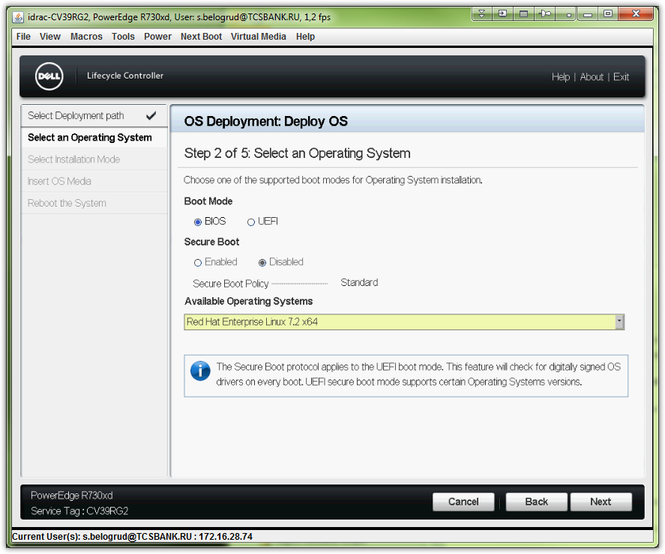

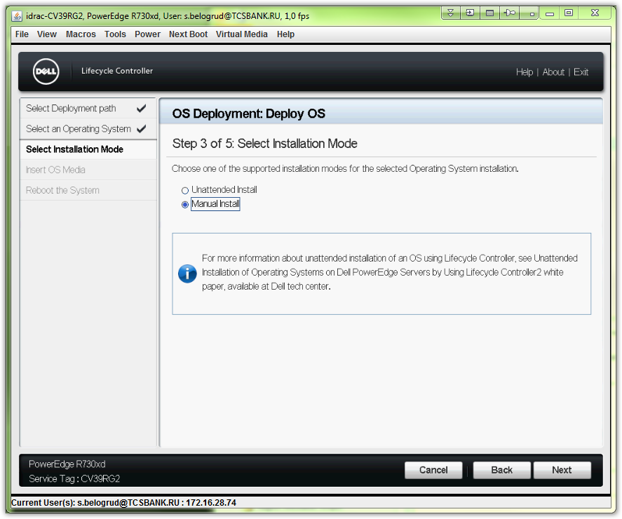

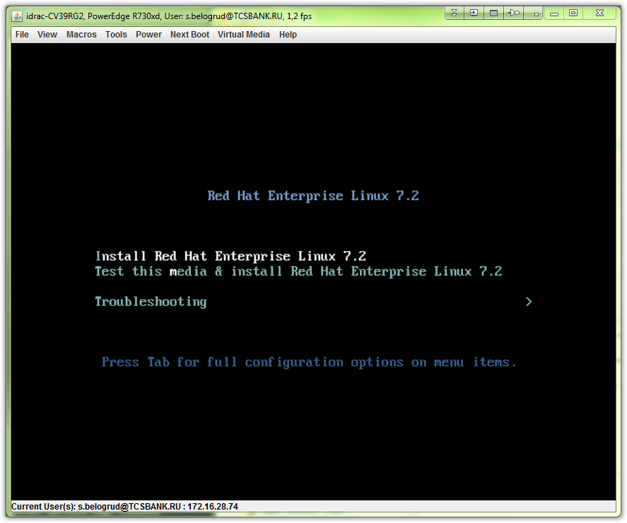

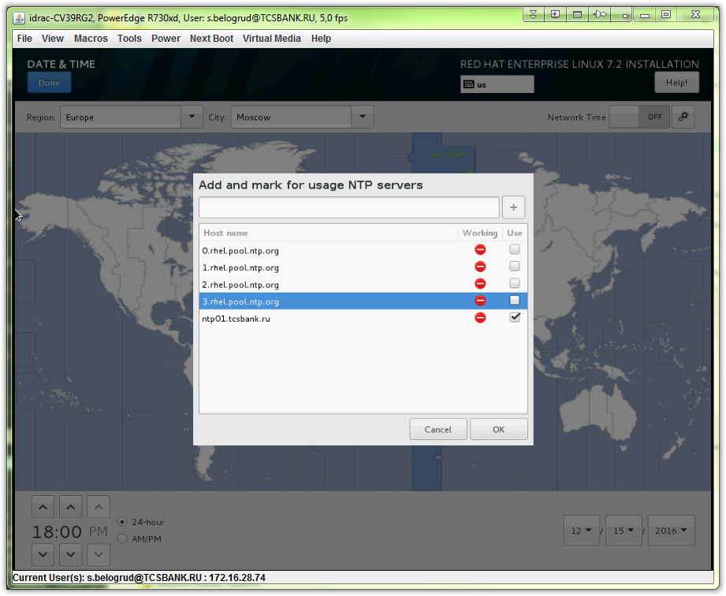

# Here I tried to define default route, but it was totaly useless. It should be avoid.
# I’d tried several ways to add it - all of them gave me nothing.
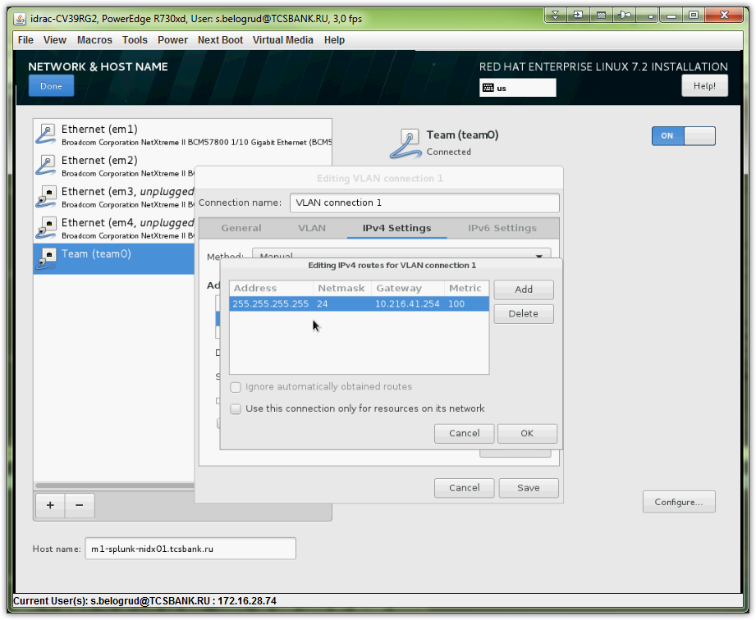
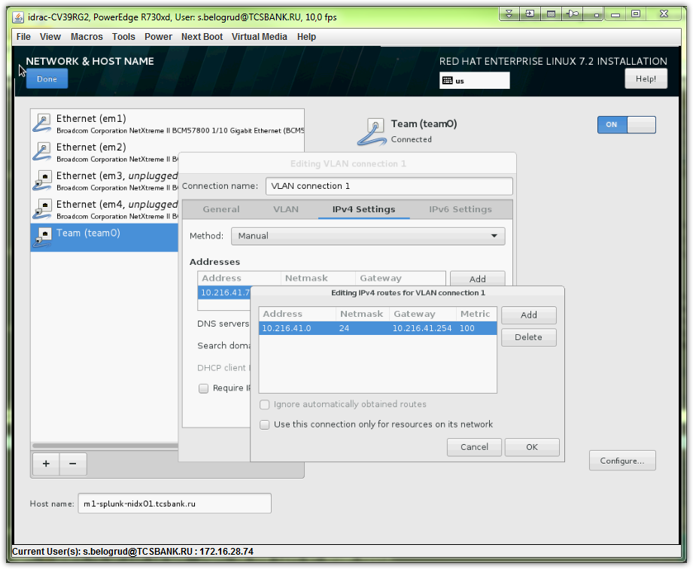

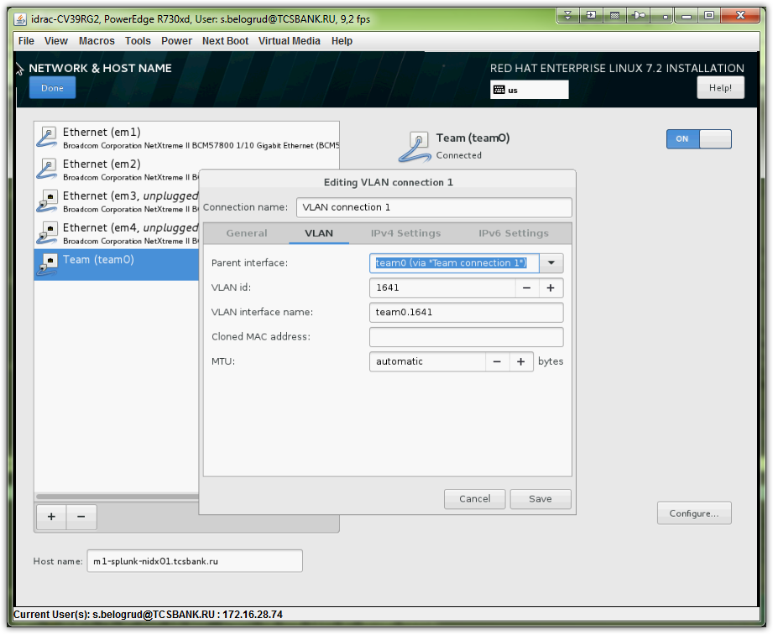
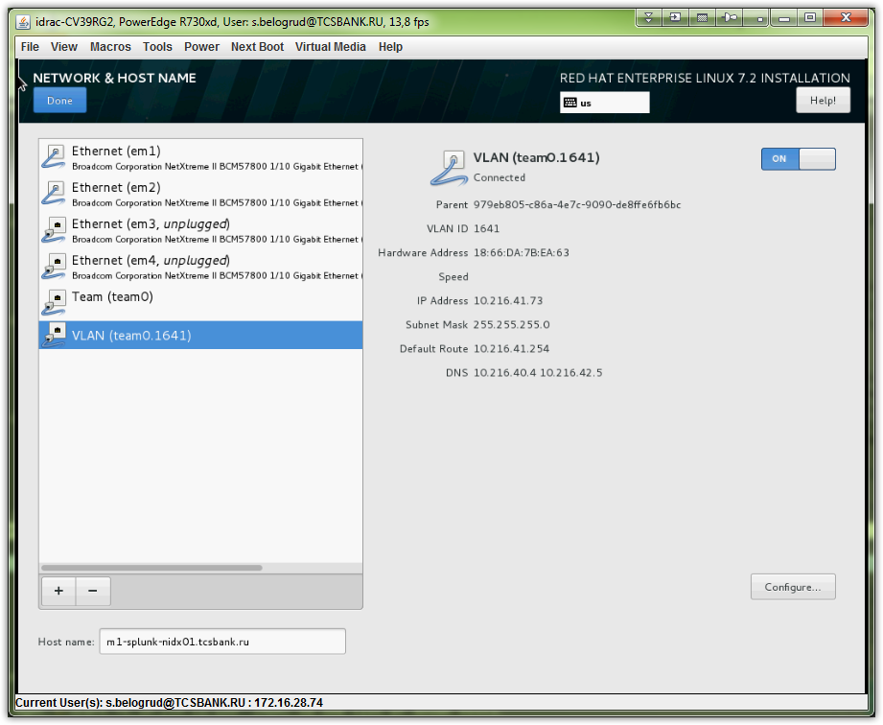

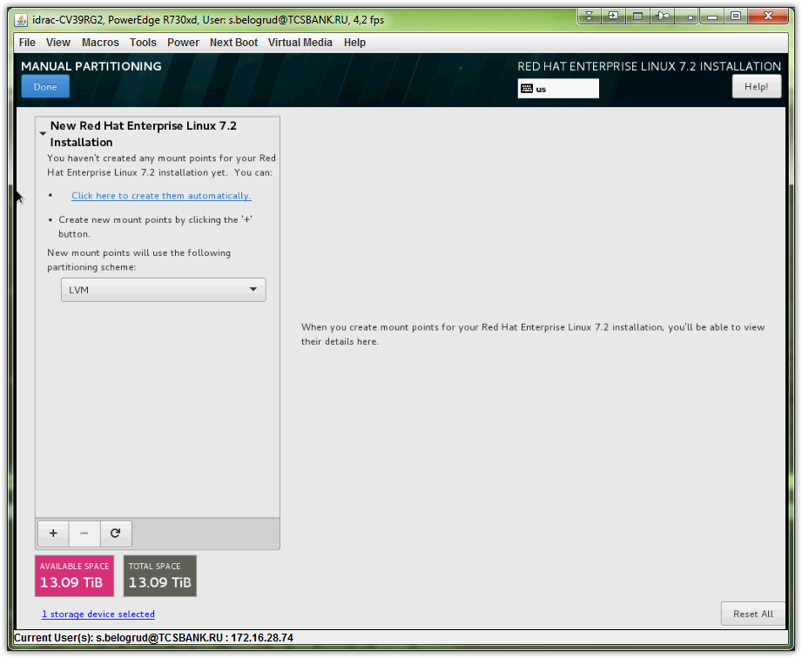
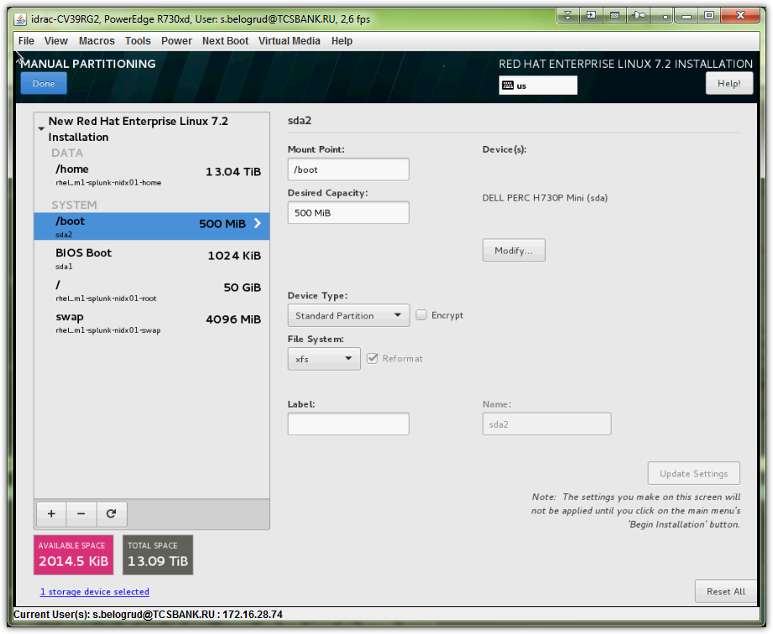
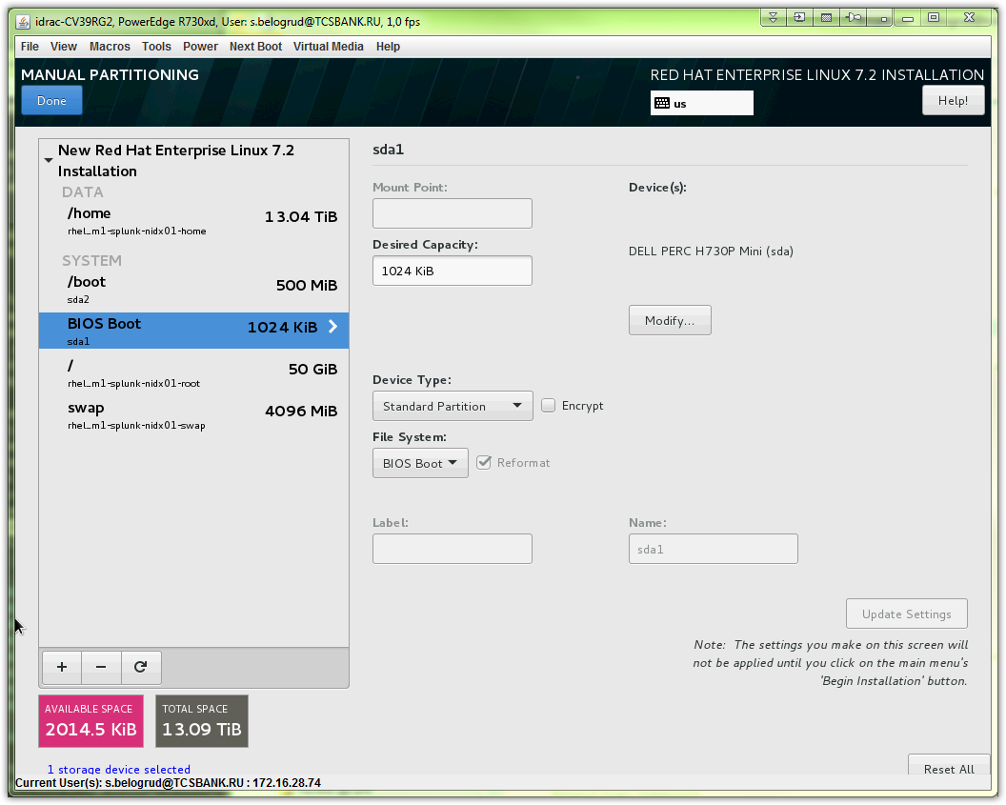
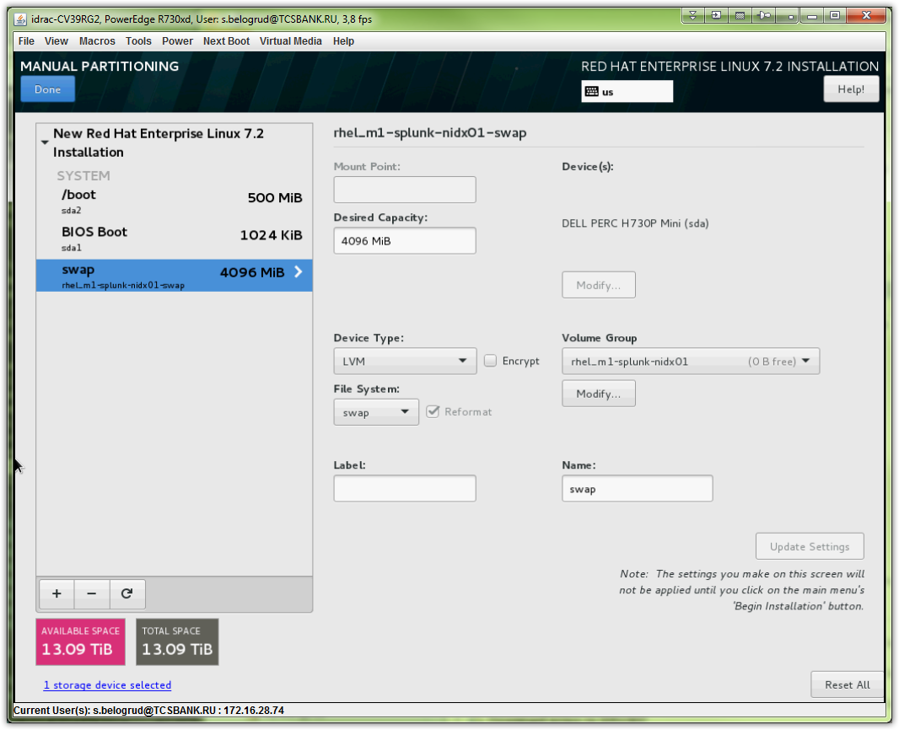
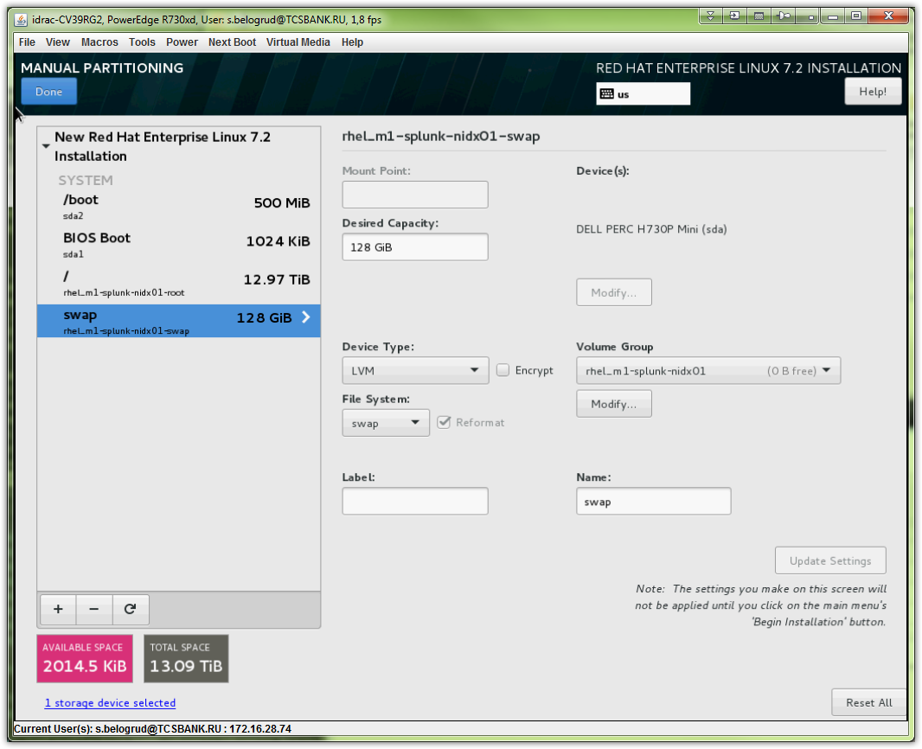
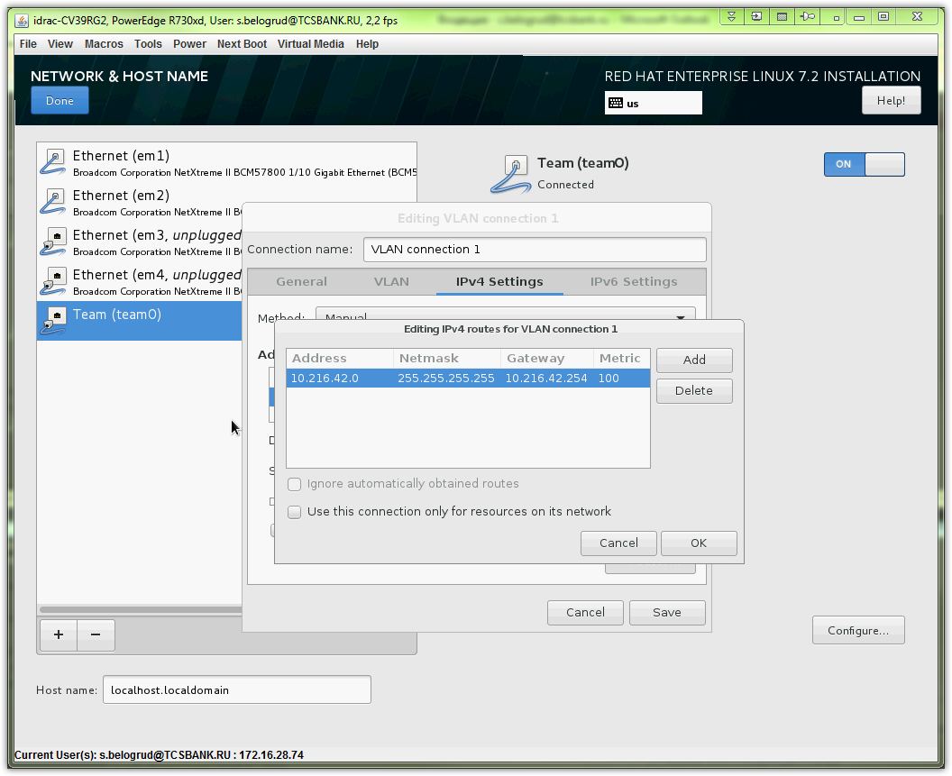
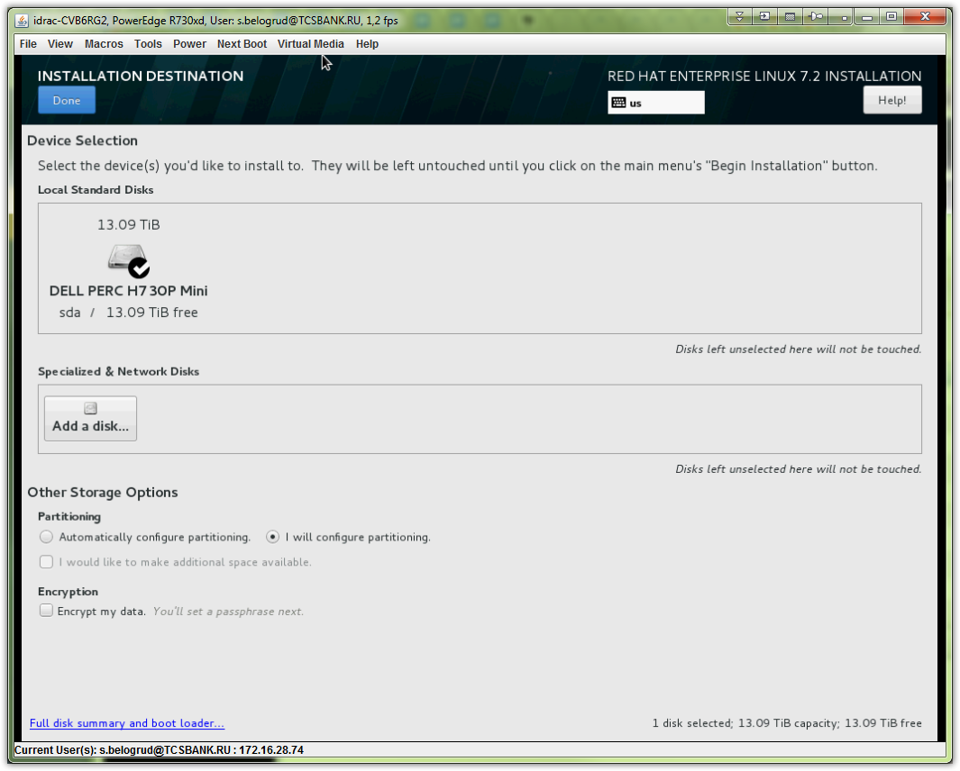
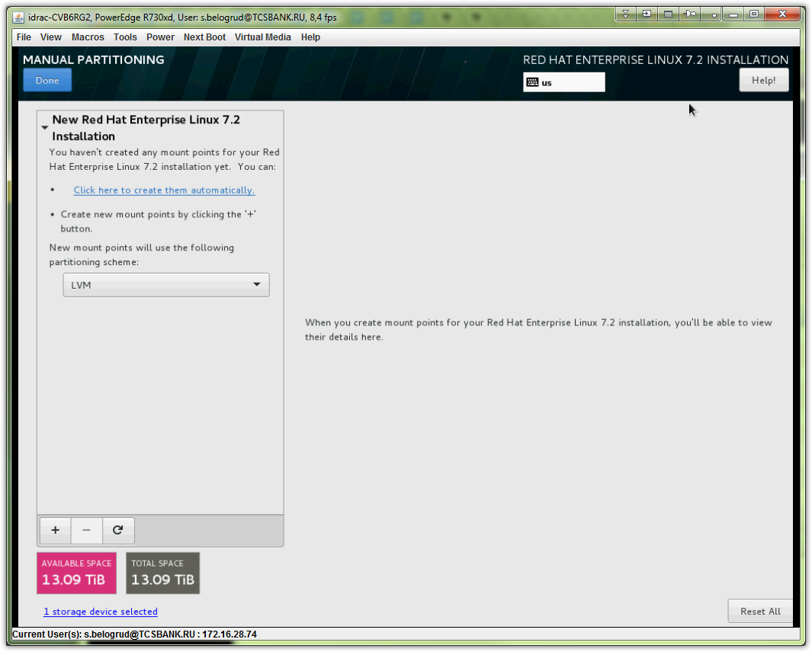
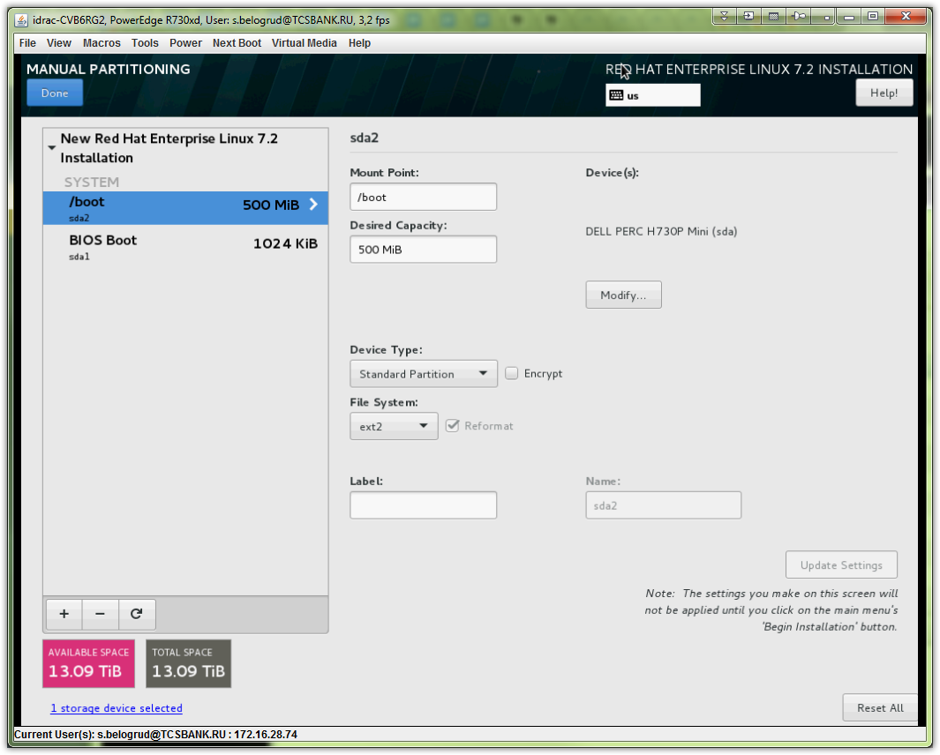
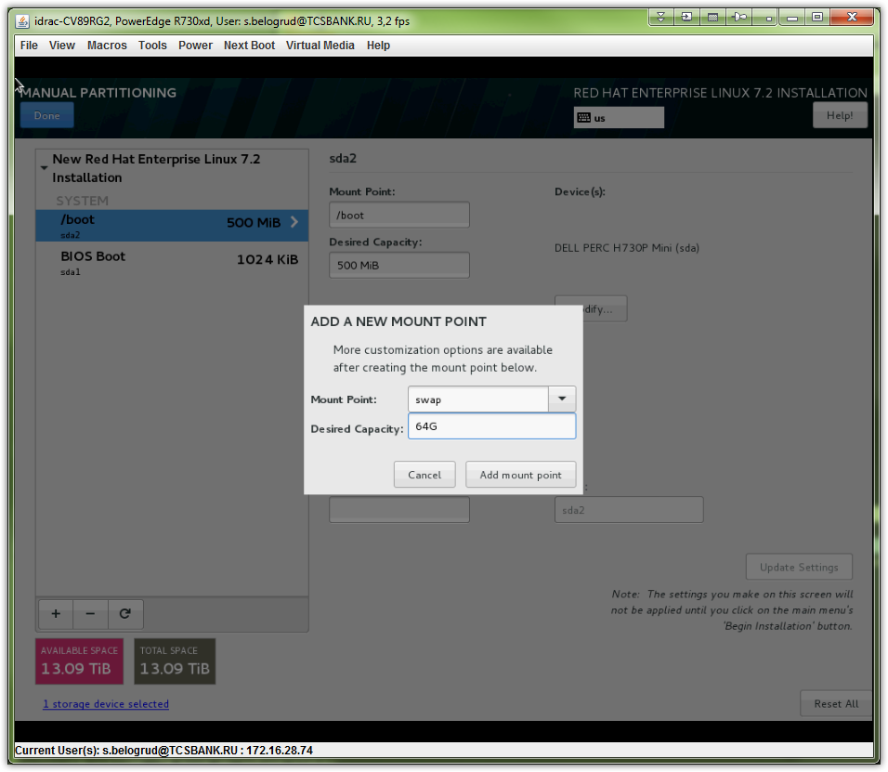
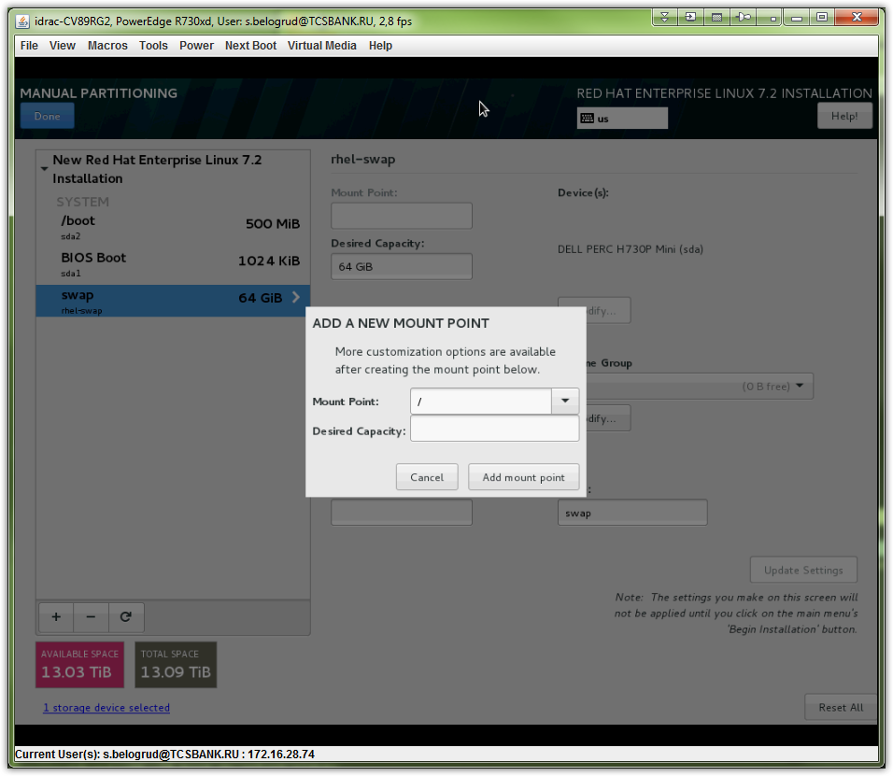
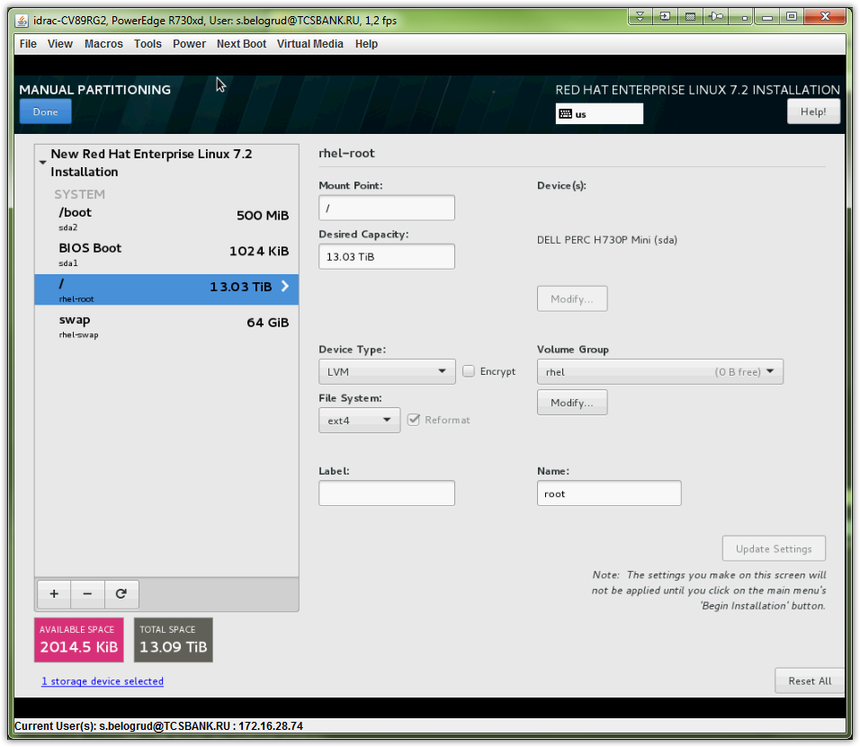
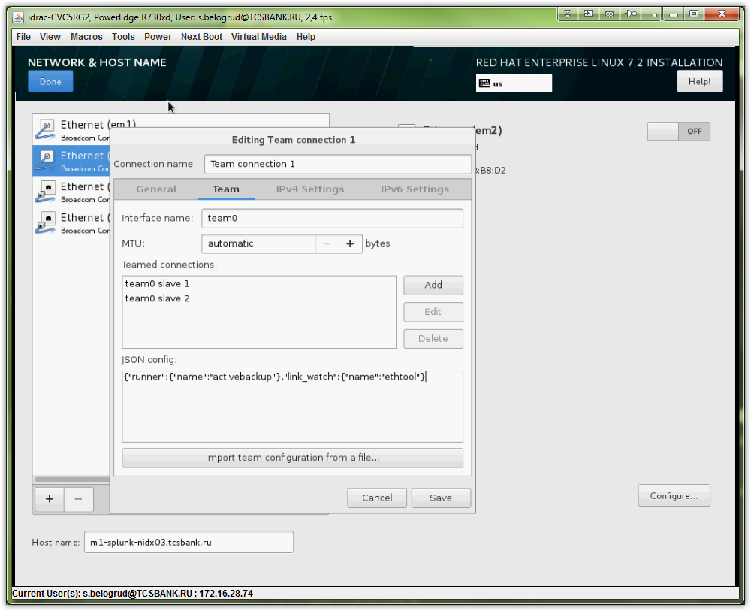
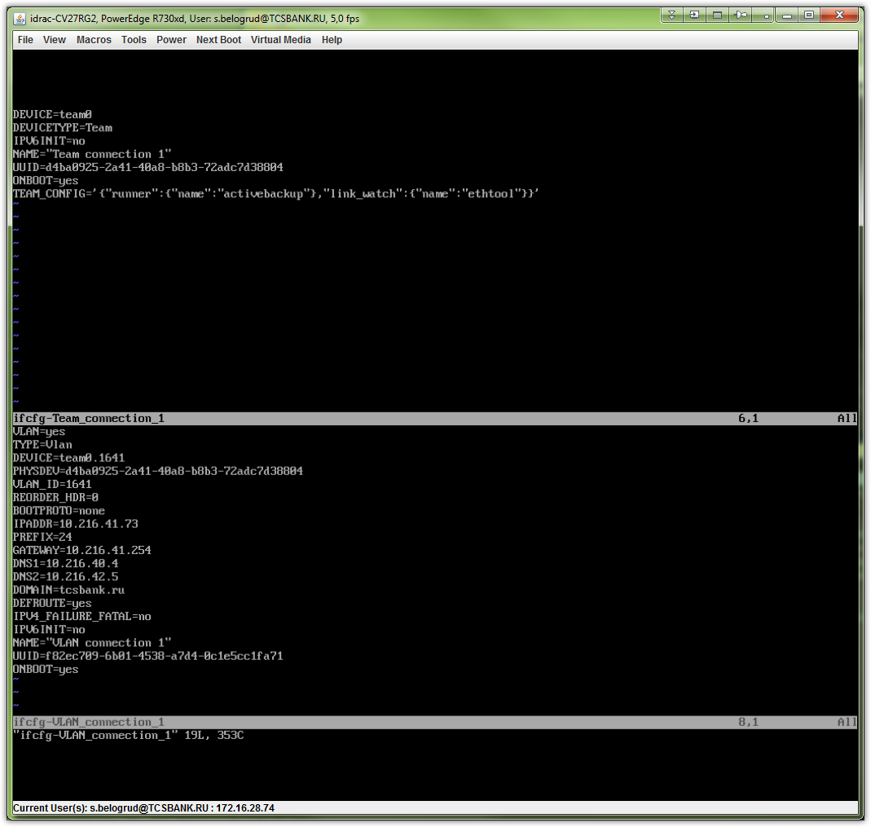

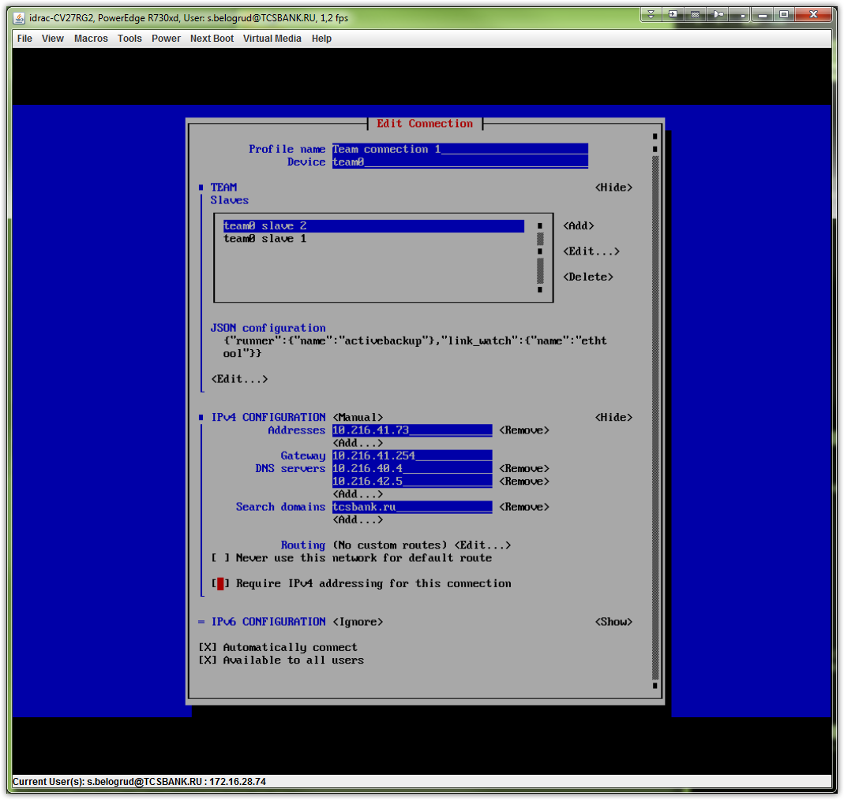
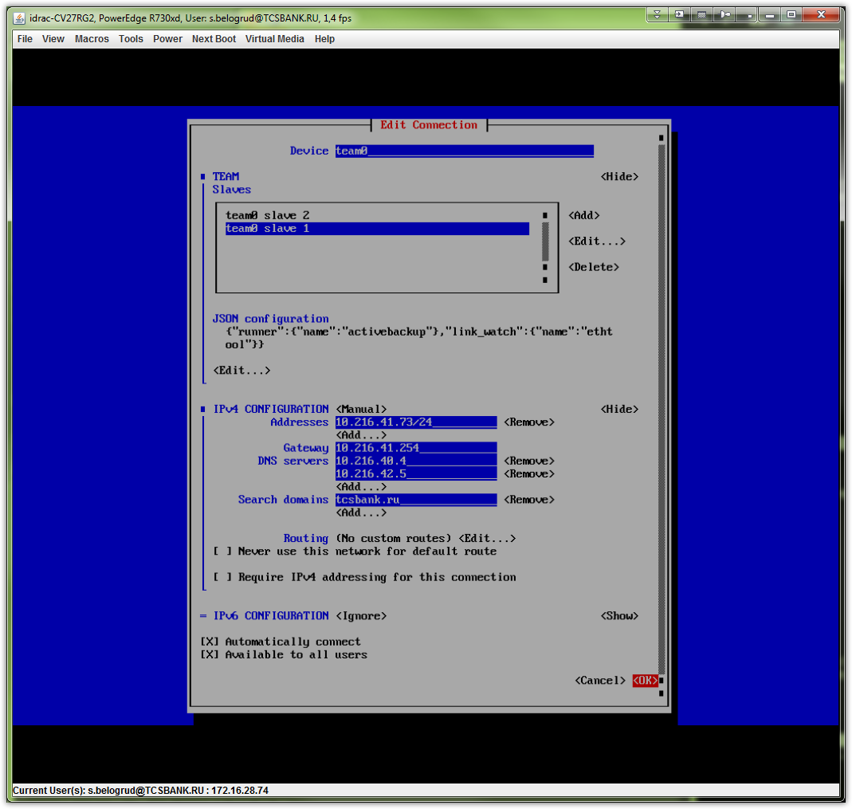
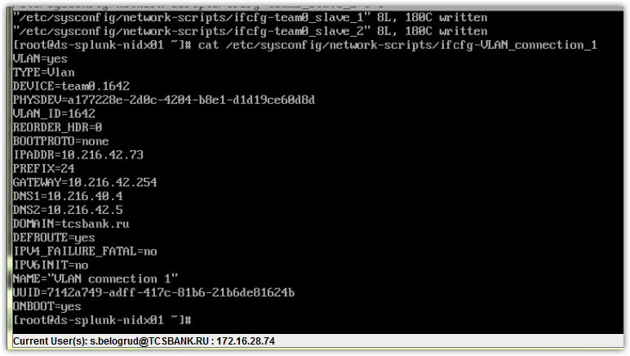
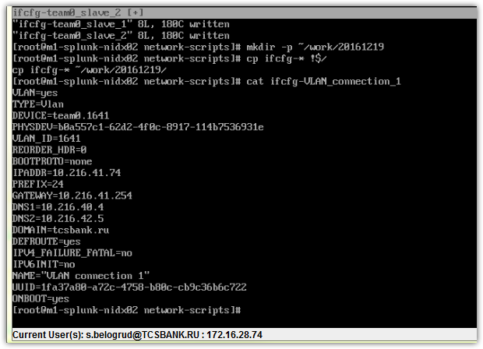
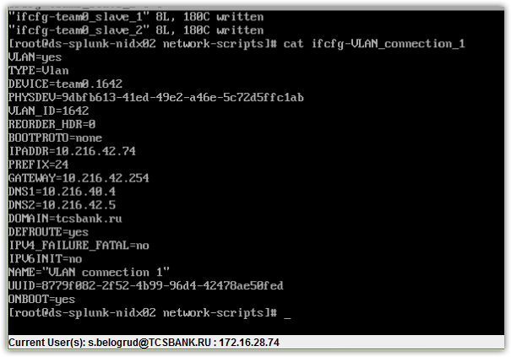
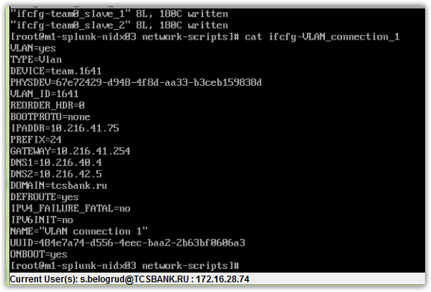
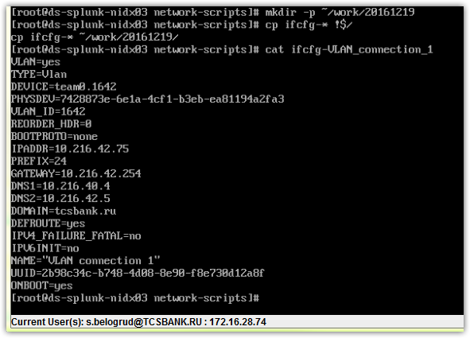
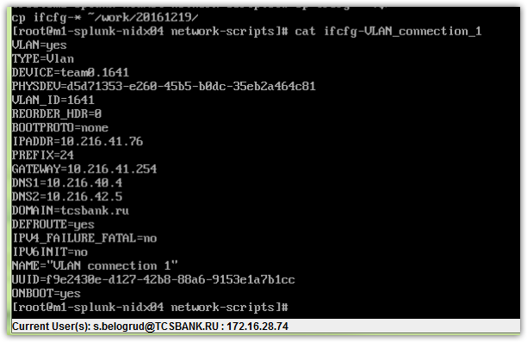

# This untagged network we have at the end.

/etc/sysconfig/network-scripts/ifcfg-em1
TYPE=Ethernet
DEFROUTE=yes
PEERDNS=yes
PEERROUTES=yes
IPV4_FAILURE_FATAL=no
IPV6INIT=no
IPV6_AUTOCONF=yes
IPV6_DEFROUTE=yes
IPV6_PEERDNS=yes
IPV6_PEERROUTES=yes
IPV6_FAILURE_FATAL=no
NAME=em1
UUID=3e258da2-3212-49ed-bbc9-342fcd524b8c
DEVICE=em1
ONBOOT=no

/etc/sysconfig/network-scripts/ifcfg-em2
TYPE=Ethernet
DEFROUTE=yes
PEERDNS=yes
PEERROUTES=yes
IPV4_FAILURE_FATAL=no
IPV6INIT=no
IPV6_AUTOCONF=yes
IPV6_DEFROUTE=yes
IPV6_PEERDNS=yes
IPV6_PEERROUTES=yes
IPV6_FAILURE_FATAL=no
NAME=em2
UUID=c35b0ba1-273b-49be-9b83-b7f36203b80a
DEVICE=em2
ONBOOT=no

/etc/sysconfig/network-scripts/ifcfg-em3
TYPE=Ethernet
BOOTPROTO=dhcp
DEFROUTE=yes
PEERDNS=yes
PEERROUTES=yes
IPV4_FAILURE_FATAL=no
IPV6INIT=yes
IPV6_AUTOCONF=yes
IPV6_DEFROUTE=yes
IPV6_PEERDNS=yes
IPV6_PEERROUTES=yes
IPV6_FAILURE_FATAL=no
NAME=em3
UUID=1cd46443-e87f-4cb9-ae03-b2fea54a07de
DEVICE=em3
ONBOOT=no

/etc/sysconfig/network-scripts/ifcfg-em4
TYPE=Ethernet
BOOTPROTO=dhcp
DEFROUTE=yes
PEERDNS=yes
PEERROUTES=yes
IPV4_FAILURE_FATAL=no
IPV6INIT=yes
IPV6_AUTOCONF=yes
IPV6_DEFROUTE=yes
IPV6_PEERDNS=yes
IPV6_PEERROUTES=yes
IPV6_FAILURE_FATAL=no
NAME=em4
UUID=810dbdaa-7413-4876-880c-f63fc6480c38
DEVICE=em4
ONBOOT=no

/etc/sysconfig/network-scripts/ifcfg-team0_slave_1
HWADDR=18:66:Dvim A:7B:EA:3D
NAME="team0 slave 1"
UUID=b72f1774-5628-4e23-8fee-6a0353bc3ae3
DEVICE=em1
ONBOOT=yes
TEAM_MASTER=team0
DEVICETYPE=TeamPort
TEAM_PORT_CONFIG='{"prio":100}'

/etc/sysconfig/network-scripts/ifcfg-team0_slave_2
HWADDR=18:66:DA:7B:EA:3F
NAME="team0 slave 2"
UUID=1b09537f-2d58-42c1-99d9-82a14924677e
DEVICE=em2
ONBOOT=yes
TEAM_MASTER=team0
DEVICETYPE=TeamPort
TEAM_PORT_CONFIG='{"prio":200}'

/etc/sysconfig/network-scripts/ifcfg-Team_connection_1
DEVICE=team0
DEVICETYPE=Team
IPV6INIT=no
NAME="Team connection 1"
UUID=d4ba0925-2a41-40a8-b8b3-72adc7d38804
ONBOOT=yes
TEAM_CONFIG="{\"runner\":{\"name\":\"activebackup\"},\"link_watch\":{\"name\":\"ethtool\"}}"
BOOTPROTO=none
DNS1=10.216.40.4
DNS2=10.216.42.5
DOMAIN=tcsbank.ru
DEFROUTE=yes
IPV4_FAILURE_FATAL=no
IPADDR=10.216.41.73
PREFIX=24
GATEWAY=10.216.41.254

# These servers have lot of memory. Because of it, servers are reboot unbelievable slow - 10-15 minutes was pass memory initialization.
# By default for Dell serves, set option that obey servers to reboot if they not booted normally from the first boot drive or via PXE.
# Follow options turn off this auto reboot process.
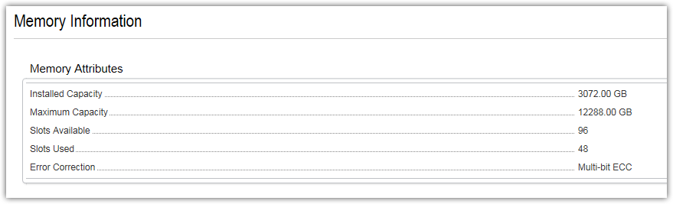
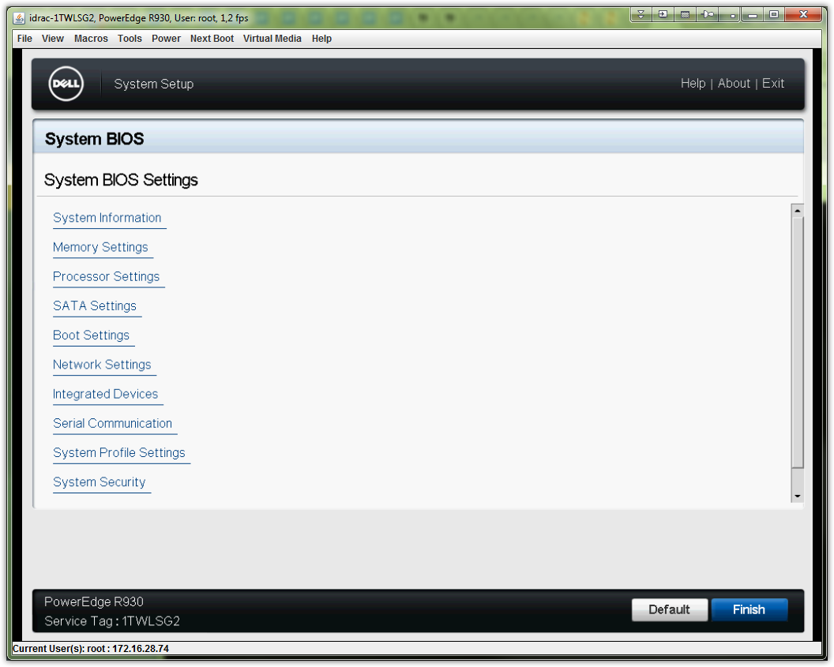
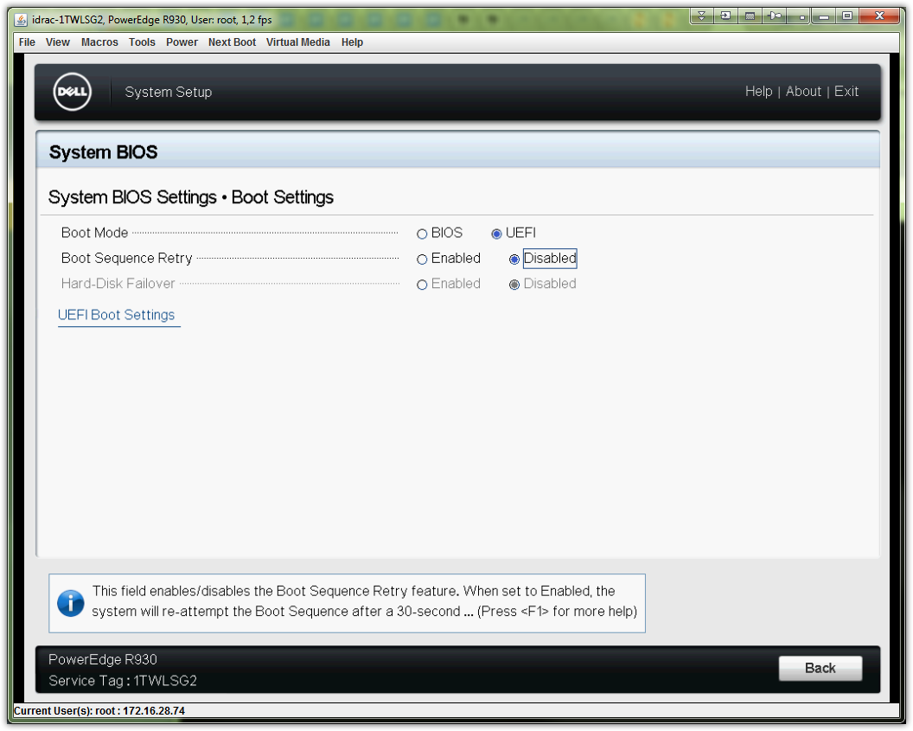

# 2.3. Change root password for iDRAC.

[support@centos00 ~]$ while read -p "Enter service tag: " var1_servicetag ; do var2_username="$( SSHPASS="$(pass common/windows-current)" sshpass -e ssh -t -oStrictHostKeyChecking=no tcsbank.ru\\s.belogrud@${var1_servicetag}.mgmt.tcsbank.ru racadm get idrac.users.2.username | grep UserName | cut -d "=" -f2 | tr -d '\r' )" ; if [ "${var2_username}" = "root" ] ; then echo -e "Service tag: ${var1_servicetag}\nServer: ${var1_servicetag}.mgmt.tcsbank.ru\nUser: ${var2_username}" ; var3_newpassword="$(pwgen -c -n -s -C 10 1)" ; echo "Password: ${var3_newpassword}" ; SSHPASS="$(pass common/windows-current)" sshpass -e ssh -t -oStrictHostKeyChecking=no tcsbank.ru\\s.belogrud@${var1_servicetag}.mgmt.tcsbank.ru racadm set idrac.users.2.password "${var3_newpassword}" | tee -a ./$(date +%Y%m%d-%H%M).racadm.set.${var1_servicetag}.txt ; else echo "No, we mightn't change pasword for user: ${var2_username}." ; fi ; done
Enter service tag: CV27RG2
Warning: Permanently added 'cv27rg2.mgmt.tcsbank.ru,10.219.9.156' (RSA) to the list of known hosts.
Connection to CV27RG2.mgmt.tcsbank.ru closed.
Service tag: CV27RG2
Server: CV27RG2.mgmt.tcsbank.ru
User: root
Password: pdpUWo8jzV
[Key=idrac.Embedded.1#Users.2]
Object value modified successfully
Connection to CV27RG2.mgmt.tcsbank.ru closed.
Enter service tag: CV77RG2
Warning: Permanently added 'cv77rg2.mgmt.tcsbank.ru,10.219.9.158' (RSA) to the list of known hosts.
Connection to CV77RG2.mgmt.tcsbank.ru closed.
Service tag: CV77RG2
Server: CV77RG2.mgmt.tcsbank.ru
User: root
Password: RtBzLH2OGX
WARNING: Default password is configured. Dell highly recommends changing user root's password immediately
[Key=idrac.Embedded.1#Users.2]
Object value modified successfully
Connection to CV77RG2.mgmt.tcsbank.ru closed.
Enter service tag: CVC5RG2
Warning: Permanently added 'cvc5rg2.mgmt.tcsbank.ru,10.219.9.155' (RSA) to the list of known hosts.
Connection to CVC5RG2.mgmt.tcsbank.ru closed.
Service tag: CVC5RG2
Server: CVC5RG2.mgmt.tcsbank.ru
User: root
Password: uikXnpds1G
WARNING: Default password is configured. Dell highly recommends changing user root's password immediately
[Key=idrac.Embedded.1#Users.2]
Object value modified successfully
Connection to CVC5RG2.mgmt.tcsbank.ru closed.
Enter service tag: CVCBRG2
Warning: Permanently added 'cvcbrg2.mgmt.tcsbank.ru,10.219.9.157' (RSA) to the list of known hosts.
Connection to CVCBRG2.mgmt.tcsbank.ru closed.
Service tag: CVCBRG2
Server: CVCBRG2.mgmt.tcsbank.ru
User: root
Password: 4Xe5aApADK
WARNING: Default password is configured. Dell highly recommends changing user root's password immediately
[Key=idrac.Embedded.1#Users.2]
Object value modified successfully
Connection to CVCBRG2.mgmt.tcsbank.ru closed.
Enter service tag: CV39RG2
Warning: Permanently added 'cv39rg2.mgmt.tcsbank.ru,10.219.11.135' (RSA) to the list of known hosts.
Connection to CV39RG2.mgmt.tcsbank.ru closed.
Service tag: CV39RG2
Server: CV39RG2.mgmt.tcsbank.ru
User: root
Password: vjWe4arlQR
[Key=idrac.Embedded.1#Users.2]
Object value modified successfully
Connection to CV39RG2.mgmt.tcsbank.ru closed.
Enter service tag: CV48RG2
Warning: Permanently added 'cv48rg2.mgmt.tcsbank.ru,10.219.11.136' (RSA) to the list of known hosts.
Connection to CV48RG2.mgmt.tcsbank.ru closed.
Service tag: CV48RG2
Server: CV48RG2.mgmt.tcsbank.ru
User: root
Password: qiuTtEZsW0
[Key=idrac.Embedded.1#Users.2]
Object value modified successfully
Connection to CV48RG2.mgmt.tcsbank.ru closed.
Enter service tag: CV89RG2
Warning: Permanently added 'cv89rg2.mgmt.tcsbank.ru,10.219.11.133' (RSA) to the list of known hosts.
Connection to CV89RG2.mgmt.tcsbank.ru closed.
Service tag: CV89RG2
Server: CV89RG2.mgmt.tcsbank.ru
User: root
Password: M1S5jV7kyd
[Key=idrac.Embedded.1#Users.2]
Object value modified successfully
Connection to CV89RG2.mgmt.tcsbank.ru closed.
Enter service tag: CVB6RG2
Warning: Permanently added 'cvb6rg2.mgmt.tcsbank.ru,10.219.11.134' (RSA) to the list of known hosts.
Connection to CVB6RG2.mgmt.tcsbank.ru closed.
Service tag: CVB6RG2
Server: CVB6RG2.mgmt.tcsbank.ru
User: root
Password: 0xGIBylDtH
[Key=idrac.Embedded.1#Users.2]
Object value modified successfully
Connection to CVB6RG2.mgmt.tcsbank.ru closed.
Enter service tag: ^C
[support@centos00 ~]$

................................................................................
................................................................................

# 2.4. Create raid array configuration.

................................................................................
................................................................................

# 6. Login on installed server with its console as root and test and add network configs.
# Was added this string into file /etc/sysconfig/network-script/ifcfg-Team_connection_1
TEAM_CONFIG='{"runner":{"name":"activebackup"},"link_watch":{"name":"ethtool"}}'

cat /etc/sysconfig/network-scripts/ifcfg-team0_slave_1
...
TEAM_PORT_CONFIG='{"prio":100}'

cat /etc/sysconfig/network-scripts/ifcfg-team0_slave_2
...
TEAM_PORT_CONFIG='{"prio":200}'

# If default route is absent (we have it).
# There is next one file should be created.
cat /etc/sysconfig/network-scripts/route-team0.1642
ADDRESS0=0.0.0.0
NETMASK0=0.0.0.0
GATEWAY0=10.216.42.254
METRIC0=0

# Test, that all serves are available from lan.

................................................................................
................................................................................

# 7. Stop and Disable firewalld on servers.

[support@centos00 ~]$ for var1_hostname in m1-splunk-nidx0{1..4} ds-splunk-nidx0{1..4} ; do export SSHPASS="$(pass common/linux-default)" ; sshpass -e ssh -t -oStrictHostKeyChecking=no -oPubkeyAuthentication=no root@${var1_hostname} '( hostname ; )' ; done
m1-splunk-nidx01.tcsbank.ru
Connection to m1-splunk-nidx01 closed.
m1-splunk-nidx02.tcsbank.ru
Connection to m1-splunk-nidx02 closed.
m1-splunk-nidx03.tcsbank.ru
Connection to m1-splunk-nidx03 closed.
m1-splunk-nidx04.tcsbank.ru
Connection to m1-splunk-nidx04 closed.
ds-splunk-nidx01.tcsbank.ru
Connection to ds-splunk-nidx01 closed.
ds-splunk-nidx02.tcsbank.ru
Connection to ds-splunk-nidx02 closed.
ds-splunk-nidx03.tcsbank.ru
Connection to ds-splunk-nidx03 closed.
ds-splunk-nidx04.tcsbank.ru
Connection to ds-splunk-nidx04 closed.
[support@centos00 ~]$

[support@centos00 ~]$ for var1_hostname in m1-splunk-nidx0{1..4} ds-splunk-nidx0{1..4} ; do export SSHPASS="$(pass common/linux-default)" ; sshpass -e ssh -t -oStrictHostKeyChecking=no -oPubkeyAuthentication=no root@${var1_hostname} "( echo ; hostname ; systemctl disable firewalld )" ; done

................................................................................

[root@ds-splunk-nidx01 ~]# tail -n 1 /etc/yum.conf
proxy=http://repo-linux.tcsbank.ru:80
[root@ds-splunk-nidx01 ~]#

[root@ds-splunk-nidx01 ~]# rpm -iv http://repo-linux.tcsbank.ru/puppetlabs/yum/puppetlabs-release-el-7.noarch.rpm
Retrieving http://repo-linux.tcsbank.ru/puppetlabs/yum/puppetlabs-release-el-7.noarch.rpm
warning: /var/tmp/rpm-tmp.7S7WSp: Header V4 RSA/SHA512 Signature, key ID 4bd6ec30: NOKEY
Preparing packages...
puppetlabs-release-22.0-2.noarch
[root@ds-splunk-nidx01 ~]# yum repolist
Loaded plugins: langpacks, product-id, search-disabled-repos, subscription-manager
This system is not registered to Red Hat Subscription Management. You can use subscription-manager to register.
puppetlabs-deps | 2.5 kB 00:00:00
puppetlabs-products | 2.5 kB 00:00:00
(1/2): puppetlabs-products/x86_64/primary_db | 69 kB 00:00:00
(2/2): puppetlabs-deps/x86_64/primary_db | 8.4 kB 00:00:01
repo id repo name status
puppetlabs-deps/x86_64 Puppet Labs Dependencies El 7 - x86_64 17
puppetlabs-products/x86_64 Puppet Labs Products El 7 - x86_64 225
repolist: 242
[root@ds-splunk-nidx01 ~]#

[root@ds-splunk-nidx01 ~]# read -s -p "Enter Proxy Password: " PROXY_PASSWORD ; echo ; read -s -p "Enter RHN Password: " RHN_PASSWORD ; subscription-manager register --proxy=mwg.gtm.tcsbank.ru:8080 --proxyuser=rhsm_user --proxypass=$PROXY_PASSWORD --username=tcsbank17012012 --password=$RHN_PASSWORD --auto-attach
Enter Proxy Password:
Enter RHN Password: Registering to: subscription.rhn.redhat.com:443/subscription
The system has been registered with ID: 7ebd6c9e-1813-467a-9a03-a0b39b43e93c

Installed Product Current Status:
Product Name: Red Hat Enterprise Linux Server
Status: Subscribed

[root@ds-splunk-nidx01 ~]#

[root@ds-splunk-nidx01 ~]# vim /etc/rhsm/rhsm.conf
...
# an http proxy server to use
proxy_hostname = mwg.gtm.tcsbank.ru

# port for http proxy server
proxy_port = 8080

# user name for authenticating to an http proxy, if needed
proxy_user = rhsm_user

# password for basic http proxy auth, if needed
proxy_password = 6eKoEvNHFS5IycxhqH5W
...

[root@ds-splunk-nidx01 ~]# yum repolist
Loaded plugins: langpacks, product-id, search-disabled-repos, subscription-manager
rhel-7-server-rpms | 3.5 kB 00:00:00
(1/3): rhel-7-server-rpms/7Server/x86_64/group | 701 kB 00:00:01
(2/3): rhel-7-server-rpms/7Server/x86_64/updateinfo | 1.8 MB 00:00:02
(3/3): rhel-7-server-rpms/7Server/x86_64/primary_db | 32 MB 00:00:19
repo id repo name status
puppetlabs-deps/x86_64 Puppet Labs Dependencies El 7 - x86_64 17
puppetlabs-products/x86_64 Puppet Labs Products El 7 - x86_64 225
rhel-7-server-rpms/7Server/x86_64 Red Hat Enterprise Linux 7 Server (RPMs) 13,573
repolist: 13,815
[root@ds-splunk-nidx01 ~]#

[root@ds-splunk-nidx01 ~]# puppet agent -t
Info: Creating a new SSL key for ds-splunk-nidx01.tcsbank.ru
Info: Caching certificate for ca
Info: csr_attributes file loading from /etc/puppet/csr_attributes.yaml
Info: Creating a new SSL certificate request for ds-splunk-nidx01.tcsbank.ru
Info: Certificate Request fingerprint (SHA256): E3:77:9A:BB:87:AB:BD:9B:06:24:27:4D:25:FA:A1:72:07:53:E6:6D:F8:16:1F:81:94:91:26:F3:37:FB:7A:56
Info: Caching certificate for ca
Exiting; no certificate found and waitforcert is disabled
[root@ds-splunk-nidx01 ~]#

[root@ds-splunk-nidx01 ~]# yum install net-snmp net-snmp-utils
Loaded plugins: langpacks, product-id, search-disabled-repos, subscription-manager
Resolving Dependencies
--> Running transaction check
---> Package net-snmp.x86_64 1:5.7.2-24.el7_2.1 will be installed
--> Processing Dependency: net-snmp-agent-libs = 1:5.7.2-24.el7_2.1 for package: 1:net-snmp-5.7.2-24.el7_2.1.x86_64
--> Processing Dependency: net-snmp-libs = 1:5.7.2-24.el7_2.1 for package: 1:net-snmp-5.7.2-24.el7_2.1.x86_64
--> Processing Dependency: libnetsnmp.so.31()(64bit) for package: 1:net-snmp-5.7.2-24.el7_2.1.x86_64
--> Processing Dependency: libnetsnmpagent.so.31()(64bit) for package: 1:net-snmp-5.7.2-24.el7_2.1.x86_64
--> Processing Dependency: libnetsnmpmibs.so.31()(64bit) for package: 1:net-snmp-5.7.2-24.el7_2.1.x86_64
--> Processing Dependency: libnetsnmptrapd.so.31()(64bit) for package: 1:net-snmp-5.7.2-24.el7_2.1.x86_64
---> Package net-snmp-utils.x86_64 1:5.7.2-24.el7_2.1 will be installed
--> Running transaction check
---> Package net-snmp-agent-libs.x86_64 1:5.7.2-24.el7_2.1 will be installed
---> Package net-snmp-libs.x86_64 1:5.7.2-24.el7_2.1 will be installed
--> Finished Dependency Resolution

Dependencies Resolved

=====================================================================================================================================================================================================
Package Arch Version Repository Size
=====================================================================================================================================================================================================
Installing:
net-snmp x86_64 1:5.7.2-24.el7_2.1 rhel-7-server-rpms 321 k
net-snmp-utils x86_64 1:5.7.2-24.el7_2.1 rhel-7-server-rpms 197 k
Installing for dependencies:
net-snmp-agent-libs x86_64 1:5.7.2-24.el7_2.1 rhel-7-server-rpms 702 k
net-snmp-libs x86_64 1:5.7.2-24.el7_2.1 rhel-7-server-rpms 747 k

Transaction Summary
=====================================================================================================================================================================================================
Install 2 Packages (+2 Dependent packages)

Total download size: 1.9 M
Installed size: 6.2 M
Is this ok [y/d/N]: y
Downloading packages:
(1/4): net-snmp-5.7.2-24.el7_2.1.x86_64.rpm | 321 kB 00:00:01
(2/4): net-snmp-agent-libs-5.7.2-24.el7_2.1.x86_64.rpm | 702 kB 00:00:01
(3/4): net-snmp-utils-5.7.2-24.el7_2.1.x86_64.rpm | 197 kB 00:00:00
(4/4): net-snmp-libs-5.7.2-24.el7_2.1.x86_64.rpm | 747 kB 00:00:01
-----------------------------------------------------------------------------------------------------------------------------------------------------------------------------------------------------
Total 684 kB/s | 1.9 MB 00:00:02
Running transaction check
Running transaction test
Transaction test succeeded
Running transaction
Installing : 1:net-snmp-libs-5.7.2-24.el7_2.1.x86_64 1/4
Installing : 1:net-snmp-agent-libs-5.7.2-24.el7_2.1.x86_64 2/4
Installing : 1:net-snmp-5.7.2-24.el7_2.1.x86_64 3/4
Installing : 1:net-snmp-utils-5.7.2-24.el7_2.1.x86_64 4/4
Verifying : 1:net-snmp-agent-libs-5.7.2-24.el7_2.1.x86_64 1/4
Verifying : 1:net-snmp-5.7.2-24.el7_2.1.x86_64 2/4
Verifying : 1:net-snmp-utils-5.7.2-24.el7_2.1.x86_64 3/4
Verifying : 1:net-snmp-libs-5.7.2-24.el7_2.1.x86_64 4/4

Installed:
net-snmp.x86_64 1:5.7.2-24.el7_2.1 net-snmp-utils.x86_64 1:5.7.2-24.el7_2.1

Dependency Installed:
net-snmp-agent-libs.x86_64 1:5.7.2-24.el7_2.1 net-snmp-libs.x86_64 1:5.7.2-24.el7_2.1

Complete!
[root@ds-splunk-nidx01 ~]#

................................................................................
................................................................................

[root@ds-splunk-nidx01 ~]# curl repo-linux/rhel7.repo
[rhel-7-server-rpms]
baseurl = http://repo-linux/rhel/$releasever/$basearch
name = Red Hat Enterprise Linux 7 Server (RPMs)
gpgkey = file:///etc/pki/rpm-gpg/RPM-GPG-KEY-redhat-release
gpgcheck = 0

[root@ds-splunk-nidx01 ~]#

................................................................................
................................................................................

[root@ds-splunk-nidx01 ~]# curl repo-linux/tcs-dell-dsu.repo.sh | sh
% Total % Received % Xferd Average Speed Time Time Time Current
Dload Upload Total Spent Left Speed
100 157 100 157 0 0 11953 0 --:--:-- --:--:-- --:--:-- 13083
[root@ds-splunk-nidx01 ~]#

[root@ds-splunk-nidx01 ~]# yum install srvadmin-idracadm7 srvadmin-idracadm dcism
Loaded plugins: langpacks, product-id, search-disabled-repos, subscription-manager
No package dcism available.
Resolving Dependencies
--> Running transaction check
---> Package srvadmin-idracadm.x86_64 0:8.1.0-4.4.12.sles11 will be installed
--> Processing Dependency: srvadmin-omilcore for package: srvadmin-idracadm-8.1.0-4.4.12.sles11.x86_64
--> Processing Dependency: libargtable2.so.0()(64bit) for package: srvadmin-idracadm-8.1.0-4.4.12.sles11.x86_64
---> Package srvadmin-idracadm7.x86_64 0:8.1.0-4.69.7.sles12 will be installed
--> Running transaction check
---> Package srvadmin-argtable2.x86_64 0:8.1.0-4.5.8.sles11 will be installed
---> Package srvadmin-omilcore.x86_64 0:8.1.0-4.85.1.sles12 will be installed
--> Processing Dependency: smbios-utils-bin for package: srvadmin-omilcore-8.1.0-4.85.1.sles12.x86_64
--> Running transaction check
---> Package smbios-utils-bin.x86_64 0:2.2.27-4.4.83.sles11 will be installed
--> Processing Dependency: libsmbios2 for package: smbios-utils-bin-2.2.27-4.4.83.sles11.x86_64
--> Running transaction check
---> Package libsmbios2.x86_64 0:2.2.27-4.4.83.sles11 will be installed
--> Finished Dependency Resolution

Dependencies Resolved

=====================================================================================================================================================================================================
Package Arch Version Repository Size
=====================================================================================================================================================================================================
Installing:
srvadmin-idracadm x86_64 8.1.0-4.4.12.sles11 tcs-dell-dsu 500 k
srvadmin-idracadm7 x86_64 8.1.0-4.69.7.sles12 tcs-dell-dsu 522 k
Installing for dependencies:
libsmbios2 x86_64 2.2.27-4.4.83.sles11 tcs-dell-dsu 257 k
smbios-utils-bin x86_64 2.2.27-4.4.83.sles11 tcs-dell-dsu 94 k
srvadmin-argtable2 x86_64 8.1.0-4.5.8.sles11 tcs-dell-dsu 36 k
srvadmin-omilcore x86_64 8.1.0-4.85.1.sles12 tcs-dell-dsu 28 k

Transaction Summary
=====================================================================================================================================================================================================
Install 2 Packages (+4 Dependent packages)

Total download size: 1.4 M
Installed size: 5.5 M
Is this ok [y/d/N]: y
Downloading packages:
(1/6): smbios-utils-bin-2.2.27-4.4.83.sles11.x86_64.rpm | 94 kB 00:00:00
(2/6): libsmbios2-2.2.27-4.4.83.sles11.x86_64.rpm | 257 kB 00:00:00
(3/6): srvadmin-argtable2-8.1.0-4.5.8.sles11.x86_64.rpm | 36 kB 00:00:00
(4/6): srvadmin-idracadm-8.1.0-4.4.12.sles11.x86_64.rpm | 500 kB 00:00:00
(5/6): srvadmin-idracadm7-8.1.0-4.69.7.sles12.x86_64.rpm | 522 kB 00:00:00
(6/6): srvadmin-omilcore-8.1.0-4.85.1.sles12.x86_64.rpm | 28 kB 00:00:00
-----------------------------------------------------------------------------------------------------------------------------------------------------------------------------------------------------
Total 6.4 MB/s | 1.4 MB 00:00:00
Running transaction check
Running transaction test
Transaction test succeeded
Running transaction
Installing : srvadmin-argtable2-8.1.0-4.5.8.sles11.x86_64 1/6
Installing : libsmbios2-2.2.27-4.4.83.sles11.x86_64 2/6
Installing : smbios-utils-bin-2.2.27-4.4.83.sles11.x86_64 3/6
Installing : srvadmin-omilcore-8.1.0-4.85.1.sles12.x86_64 4/6
**********************************************************
After the install process completes, you may need
to log out and then log in again to reset the PATH
variable to access the Server Administrator CLI utilities

**********************************************************
Installing : srvadmin-idracadm7-8.1.0-4.69.7.sles12.x86_64 5/6
Installing : srvadmin-idracadm-8.1.0-4.4.12.sles11.x86_64 6/6
Verifying : libsmbios2-2.2.27-4.4.83.sles11.x86_64 1/6
Verifying : srvadmin-argtable2-8.1.0-4.5.8.sles11.x86_64 2/6
Verifying : srvadmin-omilcore-8.1.0-4.85.1.sles12.x86_64 3/6
Verifying : smbios-utils-bin-2.2.27-4.4.83.sles11.x86_64 4/6
Verifying : srvadmin-idracadm7-8.1.0-4.69.7.sles12.x86_64 5/6
Verifying : srvadmin-idracadm-8.1.0-4.4.12.sles11.x86_64 6/6

Installed:
srvadmin-idracadm.x86_64 0:8.1.0-4.4.12.sles11 srvadmin-idracadm7.x86_64 0:8.1.0-4.69.7.sles12

Dependency Installed:
libsmbios2.x86_64 0:2.2.27-4.4.83.sles11 smbios-utils-bin.x86_64 0:2.2.27-4.4.83.sles11 srvadmin-argtable2.x86_64 0:8.1.0-4.5.8.sles11 srvadmin-omilcore.x86_64 0:8.1.0-4.85.1.sles12

Complete!
[root@ds-splunk-nidx01 ~]#

[root@ds-splunk-nidx01 ~]# curl repo-linux/tcs-dell.repo.sh | sh
% Total % Received % Xferd Average Speed Time Time Time Current
Dload Upload Total Spent Left Speed
100 172 100 172 0 0 26151 0 --:--:-- --:--:-- --:--:-- 28666
[root@ds-splunk-nidx01 ~]#

[root@ds-splunk-nidx01 ~]# sed -i 's/$releasever/6/' /etc/yum.repos.d/tcs-dell.repo

# This line is not working - error in dependencies.
# [root@ds-splunk-nidx01 ~]# yum install --disablerepo tcs-dell-dsu srvadmin-deng-snmp srvadmin-idrac-snmp srvadmin-isvc-snmp srvadmin-server-snmp srvadmin-storage-snmp srvadmin-storageservices-snmp

[root@ds-splunk-nidx01 ~]# yum install srvadmin-idracadm
Loaded plugins: langpacks, product-id, search-disabled-repos, subscription-manager
Package srvadmin-idracadm-8.1.0-4.4.12.sles11.x86_64 already installed and latest version
Nothing to do
[root@ds-splunk-nidx01 ~]# yum install dcism
Loaded plugins: langpacks, product-id, search-disabled-repos, subscription-manager
Resolving Dependencies
--> Running transaction check
---> Package dcism.x86_64 0:2.1.0-4.110.1.el6 will be installed
--> Processing Dependency: OpenIPMI for package: dcism-2.1.0-4.110.1.el6.x86_64
--> Running transaction check
---> Package OpenIPMI.x86_64 0:2.0.19-15.el7 will be installed
--> Processing Dependency: OpenIPMI-libs = 2.0.19-15.el7 for package: OpenIPMI-2.0.19-15.el7.x86_64
--> Processing Dependency: libIPMIlanserv.so.0()(64bit) for package: OpenIPMI-2.0.19-15.el7.x86_64
--> Processing Dependency: libOpenIPMI.so.0()(64bit) for package: OpenIPMI-2.0.19-15.el7.x86_64
--> Processing Dependency: libOpenIPMIcmdlang.so.0()(64bit) for package: OpenIPMI-2.0.19-15.el7.x86_64
--> Processing Dependency: libOpenIPMIglib.so.0()(64bit) for package: OpenIPMI-2.0.19-15.el7.x86_64
--> Processing Dependency: libOpenIPMIposix.so.0()(64bit) for package: OpenIPMI-2.0.19-15.el7.x86_64
--> Processing Dependency: libOpenIPMIui.so.1()(64bit) for package: OpenIPMI-2.0.19-15.el7.x86_64
--> Processing Dependency: libOpenIPMIutils.so.0()(64bit) for package: OpenIPMI-2.0.19-15.el7.x86_64
--> Running transaction check
---> Package OpenIPMI-libs.x86_64 0:2.0.19-15.el7 will be installed
--> Processing Dependency: OpenIPMI-modalias = 2.0.19-15.el7 for package: OpenIPMI-libs-2.0.19-15.el7.x86_64
--> Running transaction check
---> Package OpenIPMI-modalias.x86_64 0:2.0.19-15.el7 will be installed
--> Finished Dependency Resolution

Dependencies Resolved

=====================================================================================================================================================================================================
Package Arch Version Repository Size
=====================================================================================================================================================================================================
Installing:
dcism x86_64 2.1.0-4.110.1.el6 tcs-dell 469 k
Installing for dependencies:
OpenIPMI x86_64 2.0.19-15.el7 rhel-7-server-rpms 173 k
OpenIPMI-libs x86_64 2.0.19-15.el7 rhel-7-server-rpms 502 k
OpenIPMI-modalias x86_64 2.0.19-15.el7 rhel-7-server-rpms 15 k

Transaction Summary
=====================================================================================================================================================================================================
Install 1 Package (+3 Dependent packages)

Total download size: 1.1 M
Installed size: 3.3 M
Is this ok [y/d/N]: y
Downloading packages:
(1/4): OpenIPMI-libs-2.0.19-15.el7.x86_64.rpm | 502 kB 00:00:01
(2/4): dcism-2.1.0-4.110.1.el6.x86_64.rpm | 469 kB 00:00:00
(3/4): OpenIPMI-2.0.19-15.el7.x86_64.rpm | 173 kB 00:00:01
(4/4): OpenIPMI-modalias-2.0.19-15.el7.x86_64.rpm | 15 kB 00:00:00
-----------------------------------------------------------------------------------------------------------------------------------------------------------------------------------------------------
Total 641 kB/s | 1.1 MB 00:00:01
Running transaction check
Running transaction test
Transaction test succeeded
Running transaction
Installing : OpenIPMI-modalias-2.0.19-15.el7.x86_64 1/4
Installing : OpenIPMI-libs-2.0.19-15.el7.x86_64 2/4
Installing : OpenIPMI-2.0.19-15.el7.x86_64 3/4
Installing : dcism-2.1.0-4.110.1.el6.x86_64 4/4
Verifying : OpenIPMI-modalias-2.0.19-15.el7.x86_64 1/4
Verifying : dcism-2.1.0-4.110.1.el6.x86_64 2/4
Verifying : OpenIPMI-libs-2.0.19-15.el7.x86_64 3/4
Verifying : OpenIPMI-2.0.19-15.el7.x86_64 4/4

Installed:
dcism.x86_64 0:2.1.0-4.110.1.el6

Dependency Installed:
OpenIPMI.x86_64 0:2.0.19-15.el7 OpenIPMI-libs.x86_64 0:2.0.19-15.el7 OpenIPMI-modalias.x86_64 0:2.0.19-15.el7

Complete!
[root@ds-splunk-nidx01 ~]#

................................................................................
................................................................................

[root@ds-splunk-nidx01 ~]# subscription-manager status
+-------------------------------------------+
System Status Details
+-------------------------------------------+
Overall Status: Current

[root@ds-splunk-nidx01 ~]# subscription-manager unregister
System has been unregistered.
[root@ds-splunk-nidx01 ~]#

................................................................................
................................................................................

[root@puppet ~]# puppet cert list | grep ds-splunk
"ds-splunk-nidx01.tcsbank.ru" (SHA256) E3:77:9A:BB:87:AB:BD:9B:06:24:27:4D:25:FA:A1:72:07:53:E6:6D:F8:16:1F:81:94:91:26:F3:37:FB:7A:56
[root@puppet ~]# puppet cert sign ds-splunk-nidx01.tcsbank.ru
Notice: Signed certificate request for ds-splunk-nidx01.tcsbank.ru
Notice: Removing file Puppet::SSL::CertificateRequest ds-splunk-nidx01.tcsbank.ru at '/var/lib/puppet/ssl/ca/requests/ds-splunk-nidx01.tcsbank.ru.pem'
[root@puppet ~]#

[root@ds-splunk-nidx01 ~]# puppet agent -t

[root@ds-splunk-nidx01 ~]# puppet agent -t
Info: Retrieving pluginfacts
Info: Retrieving plugin
Info: Loading facts
Info: Caching catalog for ds-splunk-nidx01.tcsbank.ru
Info: Applying configuration version '1482154810'
Notice: Finished catalog run in 0.03 seconds
[root@ds-splunk-nidx01 ~]#

[root@ds-splunk-nidx01 ~]# systemctl enable puppet
[root@ds-splunk-nidx01 ~]# systemctl status puppet
● puppet.service - Puppet agent
Loaded: loaded (/usr/lib/systemd/system/puppet.service; enabled; vendor preset: disabled)
Active: active (running) since Mon 2016-12-19 17:50:09 MSK; 1min 43s ago
Main PID: 194146 (puppet)
CGroup: /system.slice/puppet.service
└─194146 /usr/bin/ruby /usr/bin/puppet agent --no-daemonize

Dec 19 17:50:09 ds-splunk-nidx01.tcsbank.ru systemd[1]: Started Puppet agent.
Dec 19 17:50:09 ds-splunk-nidx01.tcsbank.ru systemd[1]: Starting Puppet agent...
Dec 19 17:50:10 ds-splunk-nidx01.tcsbank.ru puppet-agent[194146]: Starting Puppet client version 3.8.7
Dec 19 17:50:10 ds-splunk-nidx01.tcsbank.ru puppet-agent[194146]: Run of Puppet configuration client already in progress; skipping (/var/lib/puppet/state/agent_catalog_run.lock exists)
[root@ds-splunk-nidx01 ~]#

[root@ds-splunk-nidx01 ~]# puppet agent -t
Info: Retrieving pluginfacts
Info: Retrieving plugin
Info: Loading facts
Info: Caching catalog for ds-splunk-nidx01.tcsbank.ru
Info: Applying configuration version '1482152890'
Error: Execution of '/usr/bin/yum -d 0 -e 0 -y list ntp' returned 1: Error: No matching Packages to list
Error: /Stage[main]/Ntp::Install/Package[ntp]/ensure: change from absent to present failed: Execution of '/usr/bin/yum -d 0 -e 0 -y list ntp' returned 1: Error: No matching Packages to list
Notice: /Stage[main]/Ntp::Config/File[/etc/ntp.conf]: Dependency Package[ntp] has failures: true
Warning: /Stage[main]/Ntp::Config/File[/etc/ntp.conf]: Skipping because of failed dependencies
Notice: /Stage[main]/Ntp::Service/Service[ntp]: Dependency Package[ntp] has failures: true
Warning: /Stage[main]/Ntp::Service/Service[ntp]: Skipping because of failed dependencies
Notice: /Stage[main]/Ntp/Anchor[ntp::end]: Dependency Package[ntp] has failures: true
Warning: /Stage[main]/Ntp/Anchor[ntp::end]: Skipping because of failed dependencies
Notice: Finished catalog run in 0.41 seconds
[root@ds-splunk-nidx01 ~]#

# Removed all added data.
[root@ds-splunk-nidx01 ~]# vim /etc/rhsm/rhsm.conf

[root@ds-splunk-nidx01 ~]# groupadd -g 571 ema && adduser -u 571 -g ema -c "Efremov Mikhail" -G wheel -m -s /bin/bash -p '$6$.GL0BSb/$db9ENx54QeyH/cVAHbcVeThes6A80KJaJ/vcdKY7HM9m6Emo4kMutY1BSLPs9IWhMxbB8wGYd0CWiPeY/yyw60' ema ; groupadd -g 504 lzn && adduser -u 504 -g lzn -c "Makhnev Nikita" -G wheel -m -s /bin/bash -p '$6$dJfNiGSD$ByOfkxlQPIbbSA91aXVPSd6Yt2D/vaJfUli/vm2TgmSGqLAYVNDi7Uy2U6EEK8AE.vXolemlQDhpowJtEJ4pr/' lzn ; groupadd -g 557 tms && adduser -u 557 -g tms -c "Aboltin Nikita" -G wheel -m -s /bin/bash -p '$6$SALTsalt$7MlFAUjjMU5aUZauiOeqIu9XY.M1AfJ.Mhy.o2dvXFoq44HdsPdKuGGA9mA1up1dXhThpPect8CC0YWFGI8Gz1' tms ; id ema ; id lzn ; id tms
uid=571(ema) gid=571(ema) groups=571(ema),10(wheel)
uid=504(lzn) gid=504(lzn) groups=504(lzn),10(wheel)
uid=557(tms) gid=557(tms) groups=557(tms),10(wheel)
[root@ds-splunk-nidx01 ~]#

................................................................................
................................................................................
................................................................................
................................................................................

[root@m1-splunk-nidx01 ~]# curl repo-linux.tcsbank.ru/rhel7.repo > /etc/yum.repos.d/tcs-rhel7.repo
% Total % Received % Xferd Average Speed Time Time Time Current
Dload Upload Total Spent Left Speed
100 198 100 198 0 0 21235 0 --:--:-- --:--:-- --:--:-- 22000
[root@m1-splunk-nidx01 ~]#

[root@m1-splunk-nidx01 ~]# yum repolist
Loaded plugins: langpacks, product-id, search-disabled-repos, subscription-manager
This system is not registered to Red Hat Subscription Management. You can use subscription-manager to register.
rhel-7-server-rpms | 3.0 kB 00:00:00
rhel-7-server-rpms/7Server/x86_64/primary_db | 21 MB 00:00:00
repo id repo name status
rhel-7-server-rpms/7Server/x86_64 Red Hat Enterprise Linux 7 Server (RPMs) 11,057
repolist: 11,057
[root@m1-splunk-nidx01 ~]#

[root@m1-splunk-nidx01 ~]# yum install http://repo-linux.tcsbank.ru/puppetlabs/yum/puppetlabs-release-el-7.noarch.rpm
Loaded plugins: langpacks, product-id, search-disabled-repos, subscription-manager
This system is not registered to Red Hat Subscription Management. You can use subscription-manager to register.
puppetlabs-release-el-7.noarch.rpm | 14 kB 00:00:00
Examining /var/tmp/yum-root-9Q4SHs/puppetlabs-release-el-7.noarch.rpm: puppetlabs-release-22.0-2.noarch
Marking /var/tmp/yum-root-9Q4SHs/puppetlabs-release-el-7.noarch.rpm to be installed
Resolving Dependencies
--> Running transaction check
---> Package puppetlabs-release.noarch 0:22.0-2 will be installed
--> Finished Dependency Resolution

Dependencies Resolved

=====================================================================================================================================================================================================
Package Arch Version Repository Size
=====================================================================================================================================================================================================
Installing:
puppetlabs-release noarch 22.0-2 /puppetlabs-release-el-7.noarch 13 k

Transaction Summary
=====================================================================================================================================================================================================
Install 1 Package

Total size: 13 k
Installed size: 13 k
Is this ok [y/d/N]: y
Downloading packages:
Running transaction check
Running transaction test
Transaction test succeeded
Running transaction
Installing : puppetlabs-release-22.0-2.noarch 1/1
Verifying : puppetlabs-release-22.0-2.noarch 1/1

Installed:
puppetlabs-release.noarch 0:22.0-2

Complete!
[root@m1-splunk-nidx01 ~]#

# Not working....
# Needs RHN registration...
[root@m1-splunk-nidx01 ~]# yum install puppet
Loaded plugins: langpacks, product-id, search-disabled-repos, subscription-manager
This system is not registered to Red Hat Subscription Management. You can use subscription-manager to register.
http://yum.puppetlabs.com/el/7/dependencies/x86_64/repodata/repomd.xml: [Errno 14] curl#7 - "Failed to connect to 2600:3c03::f03c:91ff:fedb:6b1d: Network is unreachable"
Trying other mirror.
http://yum.puppetlabs.com/el/7/dependencies/x86_64/repodata/repomd.xml: [Errno 14] curl#7 - "Failed to connect to 2600:3c03::f03c:91ff:fedb:6b1d: Network is unreachable"
Trying other mirror.
http://yum.puppetlabs.com/el/7/dependencies/x86_64/repodata/repomd.xml: [Errno 14] curl#7 - "Failed to connect to 2600:3c03::f03c:91ff:fedb:6b1d: Network is unreachable"
Trying other mirror.
http://yum.puppetlabs.com/el/7/dependencies/x86_64/repodata/repomd.xml: [Errno 14] curl#7 - "Failed to connect to 2600:3c03::f03c:91ff:fedb:6b1d: Network is unreachable"
Trying other mirror.
http://yum.puppetlabs.com/el/7/dependencies/x86_64/repodata/repomd.xml: [Errno 14] curl#7 - "Failed to connect to 2600:3c03::f03c:91ff:fedb:6b1d: Network is unreachable"
Trying other mirror.
http://yum.puppetlabs.com/el/7/dependencies/x86_64/repodata/repomd.xml: [Errno 14] curl#7 - "Failed to connect to 2600:3c03::f03c:91ff:fedb:6b1d: Network is unreachable"
Trying other mirror.
http://yum.puppetlabs.com/el/7/dependencies/x86_64/repodata/repomd.xml: [Errno 14] curl#7 - "Failed to connect to 2600:3c03::f03c:91ff:fedb:6b1d: Network is unreachable"
Trying other mirror.
http://yum.puppetlabs.com/el/7/dependencies/x86_64/repodata/repomd.xml: [Errno 14] curl#7 - "Failed to connect to 2600:3c03::f03c:91ff:fedb:6b1d: Network is unreachable"
Trying other mirror.
http://yum.puppetlabs.com/el/7/dependencies/x86_64/repodata/repomd.xml: [Errno 14] curl#7 - "Failed to connect to 2600:3c03::f03c:91ff:fedb:6b1d: Network is unreachable"
Trying other mirror.
http://yum.puppetlabs.com/el/7/dependencies/x86_64/repodata/repomd.xml: [Errno 14] curl#7 - "Failed to connect to 2600:3c03::f03c:91ff:fedb:6b1d: Network is unreachable"
Trying other mirror.

One of the configured repositories failed (Puppet Labs Dependencies El 7 - x86_64),
and yum doesn't have enough cached data to continue. At this point the only
safe thing yum can do is fail. There are a few ways to work "fix" this:

1. Contact the upstream for the repository and get them to fix the problem.

2. Reconfigure the baseurl/etc. for the repository, to point to a working
upstream. This is most often useful if you are using a newer
distribution release than is supported by the repository (and the
packages for the previous distribution release still work).

3. Disable the repository, so yum won't use it by default. Yum will then
just ignore the repository until you permanently enable it again or use
--enablerepo for temporary usage:

yum-config-manager --disable puppetlabs-deps

4. Configure the failing repository to be skipped, if it is unavailable.
Note that yum will try to contact the repo. when it runs most commands,
so will have to try and fail each time (and thus. yum will be be much
slower). If it is a very temporary problem though, this is often a nice
compromise:

yum-config-manager --save --setopt=puppetlabs-deps.skip_if_unavailable=true

failure: repodata/repomd.xml from puppetlabs-deps: [Errno 256] No more mirrors to try.
http://yum.puppetlabs.com/el/7/dependencies/x86_64/repodata/repomd.xml: [Errno 14] curl#7 - "Failed to connect to 2600:3c03::f03c:91ff:fedb:6b1d: Network is unreachable"
http://yum.puppetlabs.com/el/7/dependencies/x86_64/repodata/repomd.xml: [Errno 14] curl#7 - "Failed to connect to 2600:3c03::f03c:91ff:fedb:6b1d: Network is unreachable"
http://yum.puppetlabs.com/el/7/dependencies/x86_64/repodata/repomd.xml: [Errno 14] curl#7 - "Failed to connect to 2600:3c03::f03c:91ff:fedb:6b1d: Network is unreachable"
http://yum.puppetlabs.com/el/7/dependencies/x86_64/repodata/repomd.xml: [Errno 14] curl#7 - "Failed to connect to 2600:3c03::f03c:91ff:fedb:6b1d: Network is unreachable"
http://yum.puppetlabs.com/el/7/dependencies/x86_64/repodata/repomd.xml: [Errno 14] curl#7 - "Failed to connect to 2600:3c03::f03c:91ff:fedb:6b1d: Network is unreachable"
http://yum.puppetlabs.com/el/7/dependencies/x86_64/repodata/repomd.xml: [Errno 14] curl#7 - "Failed to connect to 2600:3c03::f03c:91ff:fedb:6b1d: Network is unreachable"
http://yum.puppetlabs.com/el/7/dependencies/x86_64/repodata/repomd.xml: [Errno 14] curl#7 - "Failed to connect to 2600:3c03::f03c:91ff:fedb:6b1d: Network is unreachable"
http://yum.puppetlabs.com/el/7/dependencies/x86_64/repodata/repomd.xml: [Errno 14] curl#7 - "Failed to connect to 2600:3c03::f03c:91ff:fedb:6b1d: Network is unreachable"
http://yum.puppetlabs.com/el/7/dependencies/x86_64/repodata/repomd.xml: [Errno 14] curl#7 - "Failed to connect to 2600:3c03::f03c:91ff:fedb:6b1d: Network is unreachable"
http://yum.puppetlabs.com/el/7/dependencies/x86_64/repodata/repomd.xml: [Errno 14] curl#7 - "Failed to connect to 2600:3c03::f03c:91ff:fedb:6b1d: Network is unreachable"
[root@m1-splunk-nidx01 ~]#
[root@m1-splunk-nidx01 ~]#

[root@m1-splunk-nidx01 ~]# echo "proxy=http://repo-linux.tcsbank.ru:80" >> /etc/yum.conf

[root@m1-splunk-nidx01 ~]# read -s -p "Enter Proxy Password: " PROXY_PASSWORD ; echo ; read -s -p "Enter RHN Password: " RHN_PASSWORD ; subscription-manager register --proxy=mwg.gtm.tcsbank.ru:8080 --proxyuser=rhsm_user --proxypass=$PROXY_PASSWORD --username=tcsbank17012012 --password=$RHN_PASSWORD --auto-attach
Enter Proxy Password:
Enter RHN Password: Registering to: subscription.rhn.redhat.com:443/subscription
The system has been registered with ID: 37ce7e8e-e987-4095-9a6f-61307a7d23d9

Installed Product Current Status:
Product Name: Red Hat Enterprise Linux Server
Status: Subscribed

[root@m1-splunk-nidx01 ~]#

[root@m1-splunk-nidx01 ~]# sed -i.backup 's/proxy_hostname =/proxy_hostname = mwg.gtm.tcsbank.ru/;s/proxy_port =/proxy_port = 8080/;s/proxy_user =/proxy_user = rhsm_user/;s/proxy_password =/proxy_password = 6eKoEvNHFS5IycxhqH5W/' /etc/rhsm/rhsm.conf
[root@m1-splunk-nidx01 ~]#

[root@m1-splunk-nidx01 ~]# yum repolist
Loaded plugins: langpacks, product-id, search-disabled-repos, subscription-manager
Repository rhel-7-server-rpms is listed more than once in the configuration
puppetlabs-deps | 2.5 kB 00:00:00
puppetlabs-products | 2.5 kB 00:00:00
rhel-7-server-rpms | 3.5 kB 00:00:00
Not using downloaded repomd.xml because it is older than what we have:
Current : Sat Dec 17 11:15:41 2016
Downloaded: Thu Dec 15 01:33:24 2016
(1/2): puppetlabs-deps/x86_64/primary_db | 8.4 kB 00:00:00
(2/2): puppetlabs-products/x86_64/primary_db | 69 kB 00:00:00
repo id repo name status
puppetlabs-deps/x86_64 Puppet Labs Dependencies El 7 - x86_64 17
puppetlabs-products/x86_64 Puppet Labs Products El 7 - x86_64 225
rhel-7-server-rpms/7Server/x86_64 Red Hat Enterprise Linux 7 Server (RPMs) 11,057
repolist: 11,299
[root@m1-splunk-nidx01 ~]#

[root@m1-splunk-nidx01 ~]# puppet agent -t
Info: Creating a new SSL key for m1-splunk-nidx01.tcsbank.ru
Info: Caching certificate for ca
Info: csr_attributes file loading from /etc/puppet/csr_attributes.yaml
Info: Creating a new SSL certificate request for m1-splunk-nidx01.tcsbank.ru
Info: Certificate Request fingerprint (SHA256): 3B:FF:FE:EC:8D:66:DF:25:23:C1:25:B3:54:C6:9B:6D:EB:B2:32:77:B4:E7:B7:8E:E6:BE:1D:93:21:90:2E:7E
Info: Caching certificate for ca
Exiting; no certificate found and waitforcert is disabled
[root@m1-splunk-nidx01 ~]#

[root@puppet ~]# puppet cert list | awk "/-splunk-/{print}"
"m1-splunk-nidx01.tcsbank.ru" (SHA256) 3B:FF:FE:EC:8D:66:DF:25:23:C1:25:B3:54:C6:9B:6D:EB:B2:32:77:B4:E7:B7:8E:E6:BE:1D:93:21:90:2E:7E
[root@puppet ~]#

#[root@puppet ~]# puppet cert sign $(puppet cert list | awk "/-splunk-/{print \$1}" | sed 's/"//g')
Notice: Signed certificate request for m1-splunk-nidx01.tcsbank.ru
Notice: Removing file Puppet::SSL::CertificateRequest m1-splunk-nidx01.tcsbank.ru at '/var/lib/puppet/ssl/ca/requests/m1-splunk-nidx01.tcsbank.ru.pem'
[root@puppet ~]#

[root@m1-splunk-nidx01 ~]# puppet agent -t
Info: Retrieving pluginfacts
Info: Retrieving plugin
Info: Loading facts
Info: Caching catalog for m1-splunk-nidx01.tcsbank.ru
Info: Applying configuration version '1482154270'
Notice: Finished catalog run in 0.15 seconds
[root@m1-splunk-nidx01 ~]#

[root@m1-splunk-nidx01 ~]# groupadd -g 571 ema && adduser -u 571 -g ema -c "Efremov Mikhail" -G wheel -m -s /bin/bash -p '$6$.GL0BSb/$db9ENx54QeyH/cVAHbcVeThes6A80KJaJ/vcdKY7HM9m6Emo4kMutY1BSLPs9IWhMxbB8wGYd0CWiPeY/yyw60' ema ; groupadd -g 504 lzn && adduser -u 504 -g lzn -c "Makhnev Nikita" -G wheel -m -s /bin/bash -p '$6$dJfNiGSD$ByOfkxlQPIbbSA91aXVPSd6Yt2D/vaJfUli/vm2TgmSGqLAYVNDi7Uy2U6EEK8AE.vXolemlQDhpowJtEJ4pr/' lzn ; groupadd -g 557 tms && adduser -u 557 -g tms -c "Aboltin Nikita" -G wheel -m -s /bin/bash -p '$6$SALTsalt$7MlFAUjjMU5aUZauiOeqIu9XY.M1AfJ.Mhy.o2dvXFoq44HdsPdKuGGA9mA1up1dXhThpPect8CC0YWFGI8Gz1' tms ; id ema ; id lzn ; id tms
uid=571(ema) gid=571(ema) groups=571(ema),10(wheel)
uid=504(lzn) gid=504(lzn) groups=504(lzn),10(wheel)
uid=557(tms) gid=557(tms) groups=557(tms),10(wheel)
[root@m1-splunk-nidx01 ~]#

[root@m1-splunk-nidx01 ~]# curl repo-linux/tcs-dell-dsu.repo.sh | sh
% Total % Received % Xferd Average Speed Time Time Time Current
Dload Upload Total Spent Left Speed
100 157 100 157 0 0 20336 0 --:--:-- --:--:-- --:--:-- 22428
[root@m1-splunk-nidx01 ~]#

[root@m1-splunk-nidx01 ~]# yum install srvadmin-idracadm7 srvadmin-idracadm dcism

[root@m1-splunk-nidx01 ~]# curl repo-linux/tcs-dell.repo.sh | sh
% Total % Received % Xferd Average Speed Time Time Time Current
Dload Upload Total Spent Left Speed
100 172 100 172 0 0 26514 0 --:--:-- --:--:-- --:--:-- 28666
[root@m1-splunk-nidx01 ~]# sed -i 's/$releasever/6/' /etc/yum.repos.d/tcs-dell.repo

[root@m1-splunk-nidx01 ~]# subscription-manager status
+-------------------------------------------+
System Status Details
+-------------------------------------------+
Overall Status: Current

[root@m1-splunk-nidx01 ~]# subscription-manager unregister
System has been unregistered.
[root@m1-splunk-nidx01 ~]# subscription-manager status
+-------------------------------------------+
System Status Details
+-------------------------------------------+
Overall Status: Unknown

[root@m1-splunk-nidx01 ~]#

[root@m1-splunk-nidx01 ~]# mv /etc/rhsm/rhsm.conf{.backup,}
mv: overwrite ‘/etc/rhsm/rhsm.conf’? y
[root@m1-splunk-nidx01 ~]#

[root@m1-splunk-nidx01 ~]# systemctl enable puppet

................................................................................
................................................................................

[root@m1-splunk-nidx02 ~]# echo "proxy=http://repo-linux.tcsbank.ru:80" >> /etc/yum.conf
[root@m1-splunk-nidx02 ~]# curl repo-linux.tcsbank.ru/rhel7.repo > /etc/yum.repos.d/tcs-rhel7.repo
[root@m1-splunk-nidx02 ~]# yum -y install http://repo-linux.tcsbank.ru/puppetlabs/yum/puppetlabs-release-el-7.noarch.rpm

[root@m1-splunk-nidx02 ~]# read -s -p "Enter Proxy Password: " PROXY_PASSWORD ; echo ; read -s -p "Enter RHN Password: " RHN_PASSWORD ; subscription-manager register --proxy=mwg.gtm.tcsbank.ru:8080 --proxyuser=rhsm_user --proxypass=$PROXY_PASSWORD --username=tcsbank17012012 --password=$RHN_PASSWORD --auto-attach

[root@m1-splunk-nidx02 ~]# sed -i.backup 's/proxy_hostname =/proxy_hostname = mwg.gtm.tcsbank.ru/;s/proxy_port =/proxy_port = 8080/;s/proxy_user =/proxy_user = rhsm_user/;s/proxy_password =/proxy_password = 6eKoEvNHFS5IycxhqH5W/' /etc/rhsm/rhsm.conf

[root@m1-splunk-nidx02 ~]# yum repolist

[root@m1-splunk-nidx02 ~]# yum -y install puppet
[root@m1-splunk-nidx02 ~]# puppet agent -t
[root@puppet ~]# puppet cert list | awk "/-splunk-/{print}"
"m1-splunk-nidx02.tcsbank.ru" (SHA256) D3:4D:77:86:CD:61:1D:87:F4:EE:DE:8D:6A:C8:4B:4A:1C:68:C0:A3:39:FC:21:EB:6B:E4:30:EF:0A:85:06:37
#[root@puppet ~]# puppet cert sign $(puppet cert list | awk "/-splunk-/{print \$1}" | sed 's/"//g')
[root@m1-splunk-nidx02 ~]# puppet agent -t
[root@m1-splunk-nidx02 ~]# puppet agent -t
[root@m1-splunk-nidx02 ~]# systemctl status puppet
[root@m1-splunk-nidx02 ~]# curl repo-linux/tcs-dell-dsu.repo.sh | sh
[root@m1-splunk-nidx02 ~]# yum -y install srvadmin-idracadm7 srvadmin-idracadm dcism

[root@m1-splunk-nidx02 ~]# curl repo-linux/tcs-dell.repo.sh | sh
[root@m1-splunk-nidx02 ~]# sed -i 's/$releasever/6/' /etc/yum.repos.d/tcs-dell.repo
[root@m1-splunk-nidx02 ~]# subscription-manager unregister
[root@m1-splunk-nidx02 ~]# mv /etc/rhsm/rhsm.conf{.backup,}

# Create users ema, lzn, tms.

................................................................................

[support@centos00 ~]$ for var1_hostname in m1-splunk-nidx0{1..4} ds-splunk-nidx0{1..4} ; do export SSHPASS="$(pass common/linux-default)" ; sshpass -e ssh -t -oStrictHostKeyChecking=no -oPubkeyAuthentication=no root@${var1_hostname} '( echo ; hostname ; systemctl enable puppet )' ; done

[support@centos00 ~]$ for var1_hostname in m1-splunk-nidx0{1..4} ds-splunk-nidx0{1..4} ; do export SSHPASS="$(pass common/linux-default)" ; sshpass -e ssh -t -oStrictHostKeyChecking=no -oPubkeyAuthentication=no root@${var1_hostname} '( echo ; hostname ; systemctl status puppet )' ; done

................................................................................

[support@centos00 ~]$ for var1_hostname in m1-splunk-nidx0{1..4} ds-splunk-nidx0{1..4} ; do export SSHPASS="$(pass common/linux-default)" ; sshpass -e ssh -t -oStrictHostKeyChecking=no -oPubkeyAuthentication=no root@${var1_hostname} '( echo ; hostname ; ls -A1 /etc/sysctl.d/ )' ; done

m1-splunk-nidx01.tcsbank.ru
99-sysctl.conf
Connection to m1-splunk-nidx01 closed.

m1-splunk-nidx02.tcsbank.ru
99-sysctl.conf
Connection to m1-splunk-nidx02 closed.

m1-splunk-nidx03.tcsbank.ru
99-sysctl.conf
Connection to m1-splunk-nidx03 closed.

m1-splunk-nidx04.tcsbank.ru
99-sysctl.conf
Connection to m1-splunk-nidx04 closed.

ds-splunk-nidx01.tcsbank.ru
99-sysctl.conf
Connection to ds-splunk-nidx01 closed.

ds-splunk-nidx02.tcsbank.ru
99-sysctl.conf
Connection to ds-splunk-nidx02 closed.

ds-splunk-nidx03.tcsbank.ru
99-sysctl.conf
Connection to ds-splunk-nidx03 closed.

ds-splunk-nidx04.tcsbank.ru
99-sysctl.conf
Connection to ds-splunk-nidx04 closed.
[support@centos00 ~]$ for var1_hostname in m1-splunk-nidx0{1..4} ds-splunk-nidx0{1..4} ; do export SSHPASS="$(pass common/linux-default)" ; sshpass -e ssh -t -oStrictHostKeyChecking=no -oPubkeyAuthentication=no root@${var1_hostname} '( echo ; hostname ; echo -n "# To disable for all interfaces\nnet.ipv6.conf.all.disable_ipv6 = 1" >> /etc/sysctl.d/ipv6.conf )' ; done

m1-splunk-nidx01.tcsbank.ru
Connection to m1-splunk-nidx01 closed.

m1-splunk-nidx02.tcsbank.ru
Connection to m1-splunk-nidx02 closed.

m1-splunk-nidx03.tcsbank.ru
Connection to m1-splunk-nidx03 closed.

m1-splunk-nidx04.tcsbank.ru
Connection to m1-splunk-nidx04 closed.

ds-splunk-nidx01.tcsbank.ru
Connection to ds-splunk-nidx01 closed.

ds-splunk-nidx02.tcsbank.ru
Connection to ds-splunk-nidx02 closed.

ds-splunk-nidx03.tcsbank.ru
Connection to ds-splunk-nidx03 closed.

ds-splunk-nidx04.tcsbank.ru
Connection to ds-splunk-nidx04 closed.
[support@centos00 ~]$ for var1_hostname in m1-splunk-nidx0{1..4} ds-splunk-nidx0{1..4} ; do export SSHPASS="$(pass common/linux-default)" ; sshpass -e ssh -t -oStrictHostKeyChecking=no -oPubkeyAuthentication=no root@${var1_hostname} '( echo ; hostname ; sysctl -p /etc/sysctl.d/ipv6.conf )' ; done

m1-splunk-nidx01.tcsbank.ru
Connection to m1-splunk-nidx01 closed.

m1-splunk-nidx02.tcsbank.ru
Connection to m1-splunk-nidx02 closed.

m1-splunk-nidx03.tcsbank.ru
Connection to m1-splunk-nidx03 closed.

m1-splunk-nidx04.tcsbank.ru
Connection to m1-splunk-nidx04 closed.

ds-splunk-nidx01.tcsbank.ru
Connection to ds-splunk-nidx01 closed.

ds-splunk-nidx02.tcsbank.ru
Connection to ds-splunk-nidx02 closed.

ds-splunk-nidx03.tcsbank.ru
Connection to ds-splunk-nidx03 closed.

ds-splunk-nidx04.tcsbank.ru
Connection to ds-splunk-nidx04 closed.
[support@centos00 ~]$

................................................................................
................................................................................

[support@centos00 ~]$ for var1_hostname in m1-splunk-nidx0{1..4} ds-splunk-nidx0{1..4} ; do export SSHPASS="$(pass common/linux-default)" ; sshpass -e ssh -t -oStrictHostKeyChecking=no -oPubkeyAuthentication=no root@${var1_hostname} '( echo ; hostname ; yum -y install net-snmp net-snmp-utils )' ; done

# In puppet add two manifests: etckeepre, nrpe.
[support@centos00 ~]$ for var1_hostname in m1-splunk-nidx0{1..4} ds-splunk-nidx0{1..4} ; do export SSHPASS="$(pass common/linux-default)" ; sshpass -e ssh -t -oStrictHostKeyChecking=no -oPubkeyAuthentication=no root@${var1_hostname} '( echo ; hostname ; puppet agent -t )' ; done

[support@centos00 ~]$ for var1_hostname in m1-splunk-nidx0{1..4} ds-splunk-nidx0{1..4} ; do export SSHPASS="$(pass common/linux-default)" ; sshpass -e ssh -t -oStrictHostKeyChecking=no -oPubkeyAuthentication=no root@${var1_hostname} '( echo ; hostname ; systemctl start snmpd.service ; systemctl status snmpd.service ; systemctl enable snmpd.service )' ; done

................................................................................
................................................................................

[root@m1-splunk-nidx01 ~]# getenforce
Enforcing
[root@m1-splunk-nidx01 ~]#

................................................................................

[root@m1-splunk-nidx01 ~]# yum list installed srvadmin-idracadm7 srvadmin-idracadm dcism
Loaded plugins: etckeeper, langpacks, product-id, search-disabled-repos, subscription-manager
This system is not registered to Red Hat Subscription Management. You can use subscription-manager to register.
Installed Packages
srvadmin-idracadm.x86_64 8.1.0-4.4.12.sles11 @tcs-dell-dsu
srvadmin-idracadm7.x86_64 8.1.0-4.69.7.sles12 @tcs-dell-dsu
[root@m1-splunk-nidx01 ~]#

[root@m1-splunk-nidx01 ~]# yum install --disablerepo tcs-dell-dsu dcism

[root@m1-splunk-nidx01 ~]# yum list installed srvadmin-idracadm7 srvadmin-idracadm dcism
Loaded plugins: etckeeper, langpacks, product-id, search-disabled-repos, subscription-manager
This system is not registered to Red Hat Subscription Management. You can use subscription-manager to register.
Installed Packages
dcism.x86_64 2.1.0-4.110.1.el6 @tcs-dell
srvadmin-idracadm.x86_64 8.1.0-4.4.12.sles11 @tcs-dell-dsu
srvadmin-idracadm7.x86_64 8.1.0-4.69.7.sles12 @tcs-dell-dsu
[root@m1-splunk-nidx01 ~]#

[root@m1-splunk-nidx01 ~]# yum install --disablerepo tcs-dell-dsu srvadmin-deng-snmp

[root@m1-splunk-nidx01 ~]# yum install --disablerepo tcs-dell-dsu srvadmin-idrac-snmp

[root@m1-splunk-nidx01 ~]# yum install --disablerepo tcs-dell-dsu srvadmin-isvc-snmp

[root@m1-splunk-nidx01 ~]# yum list --showduplicates --disablerepo tcs-dell-dsu srvadmin-server-snmp
Loaded plugins: etckeeper, langpacks, product-id, search-disabled-repos, subscription-manager
This system is not registered to Red Hat Subscription Management. You can use subscription-manager to register.
Available Packages
srvadmin-server-snmp.x86_64 8.1.0-4.3.1.el6 tcs-dell
srvadmin-server-snmp.x86_64 8.1.0-4.3.1.el6 tcs-dell
srvadmin-server-snmp.x86_64 8.4.0-2193.9883.el6 tcs-dell
[root@m1-splunk-nidx01 ~]#

[root@m1-splunk-nidx01 ~]# yum install --disablerepo tcs-dell-dsu srvadmin-server-snmp-8.1.0-4.3.1.el6
Loaded plugins: etckeeper, langpacks, product-id, search-disabled-repos, subscription-manager
This system is not registered to Red Hat Subscription Management. You can use subscription-manager to register.
Resolving Dependencies
--> Running transaction check
---> Package srvadmin-server-snmp.x86_64 0:8.1.0-4.3.1.el6 will be installed
--> Processing Dependency: srvadmin-ominst = 8.1.0 for package: srvadmin-server-snmp-8.1.0-4.3.1.el6.x86_64
--> Processing Dependency: srvadmin-base = 8.1.0 for package: srvadmin-server-snmp-8.1.0-4.3.1.el6.x86_64
--> Running transaction check
---> Package srvadmin-base.x86_64 0:8.1.0-4.3.1.el6 will be installed
--> Processing Dependency: srvadmin-smcommon = 8.1.0 for package: srvadmin-base-8.1.0-4.3.1.el6.x86_64
--> Processing Dependency: srvadmin-omacs = 8.1.0 for package: srvadmin-base-8.1.0-4.3.1.el6.x86_64
--> Processing Dependency: srvadmin-cm = 8.1.0 for package: srvadmin-base-8.1.0-4.3.1.el6.x86_64
---> Package srvadmin-ominst.x86_64 0:8.1.0-4.94.3.el6 will be installed
--> Running transaction check
---> Package srvadmin-cm.x86_64 0:8.1.0-4.1.249.el6 will be installed
---> Package srvadmin-omacs.x86_64 0:8.1.0-4.92.1.el6 will be installed
---> Package srvadmin-smcommon.x86_64 0:8.1.0-4.138.2.el6 will be installed
--> Finished Dependency Resolution

Dependencies Resolved

=====================================================================================================================================================================================================
Package Arch Version Repository Size
=====================================================================================================================================================================================================
Installing:
srvadmin-server-snmp x86_64 8.1.0-4.3.1.el6 tcs-dell 2.4 k
Installing for dependencies:
srvadmin-base x86_64 8.1.0-4.3.1.el6 tcs-dell 2.4 k
srvadmin-cm x86_64 8.1.0-4.1.249.el6 tcs-dell 70 M
srvadmin-omacs x86_64 8.1.0-4.92.1.el6 tcs-dell 2.8 M
srvadmin-ominst x86_64 8.1.0-4.94.3.el6 tcs-dell 1.5 M
srvadmin-smcommon x86_64 8.1.0-4.138.2.el6 tcs-dell 837 k

Transaction Summary
=====================================================================================================================================================================================================
Install 1 Package (+5 Dependent packages)

Total download size: 76 M
Installed size: 93 M
Is this ok [y/d/N]: y
Downloading packages:
(1/6): srvadmin-base-8.1.0-4.3.1.el6.x86_64.rpm | 2.4 kB 00:00:00
(2/6): srvadmin-omacs-8.1.0-4.92.1.el6.x86_64.rpm | 2.8 MB 00:00:00
(3/6): srvadmin-ominst-8.1.0-4.94.3.el6.x86_64.rpm | 1.5 MB 00:00:00
(4/6): srvadmin-server-snmp-8.1.0-4.3.1.el6.x86_64.rpm | 2.4 kB 00:00:00
(5/6): srvadmin-smcommon-8.1.0-4.138.2.el6.x86_64.rpm | 837 kB 00:00:00
(6/6): srvadmin-cm-8.1.0-4.1.249.el6.x86_64.rpm | 70 MB 00:00:01
-----------------------------------------------------------------------------------------------------------------------------------------------------------------------------------------------------
Total 69 MB/s | 76 MB 00:00:01
Running transaction check
Running transaction test
Transaction test succeeded
Running transaction
etckeeper: pre transaction commit
Installing : srvadmin-omacs-8.1.0-4.92.1.el6.x86_64 1/6
Installing : srvadmin-ominst-8.1.0-4.94.3.el6.x86_64 2/6
Installing : srvadmin-cm-8.1.0-4.1.249.el6.x86_64 3/6
Installing : srvadmin-smcommon-8.1.0-4.138.2.el6.x86_64 4/6
Installing : srvadmin-base-8.1.0-4.3.1.el6.x86_64 5/6
Installing : srvadmin-server-snmp-8.1.0-4.3.1.el6.x86_64 6/6
etckeeper: post transaction commit
Verifying : srvadmin-omacs-8.1.0-4.92.1.el6.x86_64 1/6
Verifying : srvadmin-ominst-8.1.0-4.94.3.el6.x86_64 2/6
Verifying : srvadmin-base-8.1.0-4.3.1.el6.x86_64 3/6
Verifying : srvadmin-smcommon-8.1.0-4.138.2.el6.x86_64 4/6
Verifying : srvadmin-server-snmp-8.1.0-4.3.1.el6.x86_64 5/6
Verifying : srvadmin-cm-8.1.0-4.1.249.el6.x86_64 6/6

Installed:
srvadmin-server-snmp.x86_64 0:8.1.0-4.3.1.el6

Dependency Installed:
srvadmin-base.x86_64 0:8.1.0-4.3.1.el6 srvadmin-cm.x86_64 0:8.1.0-4.1.249.el6 srvadmin-omacs.x86_64 0:8.1.0-4.92.1.el6 srvadmin-ominst.x86_64 0:8.1.0-4.94.3.el6
srvadmin-smcommon.x86_64 0:8.1.0-4.138.2.el6

Complete!
[root@m1-splunk-nidx01 ~]#

[root@m1-splunk-nidx01 ~]# yum install --disablerepo tcs-dell-dsu srvadmin-storage-snmp

[root@m1-splunk-nidx01 ~]# yum list --showduplicates --disablerepo tcs-dell-dsu srvadmin-storageservices-snmp
Loaded plugins: etckeeper, langpacks, product-id, search-disabled-repos, subscription-manager
This system is not registered to Red Hat Subscription Management. You can use subscription-manager to register.
Available Packages
srvadmin-storageservices-snmp.x86_64 8.1.0-4.3.1.el6 tcs-dell
srvadmin-storageservices-snmp.x86_64 8.1.0-4.3.1.el6 tcs-dell
srvadmin-storageservices-snmp.x86_64 8.4.0-2193.9883.el6 tcs-dell
[root@m1-splunk-nidx01 ~]#

[root@m1-splunk-nidx01 ~]# yum install --disablerepo tcs-dell-dsu srvadmin-storageservices-snmp-8.1.0-4.3.1.el6
Loaded plugins: etckeeper, langpacks, product-id, search-disabled-repos, subscription-manager
This system is not registered to Red Hat Subscription Management. You can use subscription-manager to register.
Resolving Dependencies
--> Running transaction check
---> Package srvadmin-storageservices-snmp.x86_64 0:8.1.0-4.3.1.el6 will be installed
--> Processing Dependency: srvadmin-sysfsutils = 8.1.0 for package: srvadmin-storageservices-snmp-8.1.0-4.3.1.el6.x86_64
--> Running transaction check
---> Package srvadmin-sysfsutils.x86_64 0:8.1.0-4.1.1.el6 will be installed
--> Finished Dependency Resolution

Dependencies Resolved

=====================================================================================================================================================================================================
Package Arch Version Repository Size
=====================================================================================================================================================================================================
Installing:
srvadmin-storageservices-snmp x86_64 8.1.0-4.3.1.el6 tcs-dell 2.6 k
Installing for dependencies:
srvadmin-sysfsutils x86_64 8.1.0-4.1.1.el6 tcs-dell 53 k

Transaction Summary
=====================================================================================================================================================================================================
Install 1 Package (+1 Dependent package)

Total download size: 56 k
Installed size: 143 k
Is this ok [y/d/N]: y
Downloading packages:
(1/2): srvadmin-storageservices-snmp-8.1.0-4.3.1.el6.x86_64.rpm | 2.6 kB 00:00:00
(2/2): srvadmin-sysfsutils-8.1.0-4.1.1.el6.x86_64.rpm | 53 kB 00:00:00
-----------------------------------------------------------------------------------------------------------------------------------------------------------------------------------------------------
Total 708 kB/s | 56 kB 00:00:00
Running transaction check
Running transaction test
Transaction test succeeded
Running transaction
etckeeper: pre transaction commit
Installing : srvadmin-sysfsutils-8.1.0-4.1.1.el6.x86_64 1/2
Installing : srvadmin-storageservices-snmp-8.1.0-4.3.1.el6.x86_64 2/2
etckeeper: post transaction commit
Verifying : srvadmin-storageservices-snmp-8.1.0-4.3.1.el6.x86_64 1/2
Verifying : srvadmin-sysfsutils-8.1.0-4.1.1.el6.x86_64 2/2

Installed:
srvadmin-storageservices-snmp.x86_64 0:8.1.0-4.3.1.el6

Dependency Installed:
srvadmin-sysfsutils.x86_64 0:8.1.0-4.1.1.el6

Complete!
[root@m1-splunk-nidx01 ~]#

[support@centos00 ~]$ for var1_hostname in m1-splunk-nidx0{1..4} ds-splunk-nidx0{1..4} ; do export SSHPASS="$(pass common/linux-default)" ; sshpass -e ssh -t -oStrictHostKeyChecking=no -oPubkeyAuthentication=no root@${var1_hostname} '( echo ; hostname ; yum -y install --disablerepo tcs-dell-dsu dcism srvadmin-deng-snmp srvadmin-idrac-snmp srvadmin-isvc-snmp srvadmin-server-snmp-8.1.0-4.3.1.el6 srvadmin-storage-snmp srvadmin-storageservices-snmp-8.1.0-4.3.1.el6 )' ; done

................................................................................
................................................................................

[support@centos00 ~]$ for var1_hostname in m1-splunk-nidx0{1..4} ds-splunk-nidx0{1..4} ; do export SSHPASS="$(pass common/linux-default)" ; sshpass -e ssh -t -oStrictHostKeyChecking=no -oPubkeyAuthentication=no root@${var1_hostname} '( echo ; hostname ; shutdown -r now )' ; done
m1-splunk-nidx01.tcsbank.ru
PolicyKit daemon disconnected from the bus.
We are no longer a registered authentication agent.
Connection to m1-splunk-nidx01 closed by remote host.
Connection to m1-splunk-nidx01 closed.

m1-splunk-nidx02.tcsbank.ru
PolicyKit daemon disconnected from the bus.
We are no longer a registered authentication agent.
Connection to m1-splunk-nidx02 closed by remote host.
Connection to m1-splunk-nidx02 closed.

m1-splunk-nidx03.tcsbank.ru
PolicyKit daemon disconnected from the bus.
We are no longer a registered authentication agent.
Connection to m1-splunk-nidx03 closed by remote host.
Connection to m1-splunk-nidx03 closed.

m1-splunk-nidx04.tcsbank.ru
PolicyKit daemon disconnected from the bus.
We are no longer a registered authentication agent.
Connection to m1-splunk-nidx04 closed by remote host.
Connection to m1-splunk-nidx04 closed.

ds-splunk-nidx01.tcsbank.ru
Connection to ds-splunk-nidx01 closed by remote host.
Connection to ds-splunk-nidx01 closed.

ds-splunk-nidx02.tcsbank.ru
PolicyKit daemon disconnected from the bus.
We are no longer a registered authentication agent.
Connection to ds-splunk-nidx02 closed by remote host.
Connection to ds-splunk-nidx02 closed.

ds-splunk-nidx03.tcsbank.ru
Connection to ds-splunk-nidx03 closed by remote host.
Connection to ds-splunk-nidx03 closed.

ds-splunk-nidx04.tcsbank.ru
PolicyKit daemon disconnected from the bus.
We are no longer a registered authentication agent.
Connection to ds-splunk-nidx04 closed by remote host.
Connection to ds-splunk-nidx04 closed.
[support@centos00 ~]$

[support@centos00 ~]$ for var1_hostname in m1-splunk-nidx0{1..4} ds-splunk-nidx0{1..4} ; do ping -c 1 ${var1_hostname} ; done
PING m1-splunk-nidx01.tcsbank.ru (10.216.41.73) 56(84) bytes of data.
64 bytes from m1-splunk-nidx01.tcsbank.ru (10.216.41.73): icmp_seq=1 ttl=58 time=2.40 ms

--- m1-splunk-nidx01.tcsbank.ru ping statistics ---
1 packets transmitted, 1 received, 0% packet loss, time 3ms
rtt min/avg/max/mdev = 2.405/2.405/2.405/0.000 ms
PING m1-splunk-nidx02.tcsbank.ru (10.216.41.74) 56(84) bytes of data.
64 bytes from m1-splunk-nidx02.tcsbank.ru (10.216.41.74): icmp_seq=1 ttl=58 time=2.17 ms

--- m1-splunk-nidx02.tcsbank.ru ping statistics ---
1 packets transmitted, 1 received, 0% packet loss, time 4ms
rtt min/avg/max/mdev = 2.174/2.174/2.174/0.000 ms
PING m1-splunk-nidx03.tcsbank.ru (10.216.41.75) 56(84) bytes of data.
64 bytes from m1-splunk-nidx03.tcsbank.ru (10.216.41.75): icmp_seq=1 ttl=58 time=1.94 ms

--- m1-splunk-nidx03.tcsbank.ru ping statistics ---
1 packets transmitted, 1 received, 0% packet loss, time 3ms
rtt min/avg/max/mdev = 1.944/1.944/1.944/0.000 ms
PING m1-splunk-nidx04.tcsbank.ru (10.216.41.76) 56(84) bytes of data.
64 bytes from m1-splunk-nidx04.tcsbank.ru (10.216.41.76): icmp_seq=1 ttl=58 time=3.09 ms

--- m1-splunk-nidx04.tcsbank.ru ping statistics ---
1 packets transmitted, 1 received, 0% packet loss, time 4ms
rtt min/avg/max/mdev = 3.097/3.097/3.097/0.000 ms
PING ds-splunk-nidx01.tcsbank.ru (10.216.42.73) 56(84) bytes of data.
64 bytes from ds-splunk-nidx01.tcsbank.ru (10.216.42.73): icmp_seq=1 ttl=58 time=2.31 ms

--- ds-splunk-nidx01.tcsbank.ru ping statistics ---
1 packets transmitted, 1 received, 0% packet loss, time 3ms
rtt min/avg/max/mdev = 2.310/2.310/2.310/0.000 ms
PING ds-splunk-nidx02.tcsbank.ru (10.216.42.74) 56(84) bytes of data.
64 bytes from ds-splunk-nidx02.tcsbank.ru (10.216.42.74): icmp_seq=1 ttl=58 time=3.69 ms

--- ds-splunk-nidx02.tcsbank.ru ping statistics ---
1 packets transmitted, 1 received, 0% packet loss, time 4ms
rtt min/avg/max/mdev = 3.692/3.692/3.692/0.000 ms
PING ds-splunk-nidx03.tcsbank.ru (10.216.42.75) 56(84) bytes of data.
64 bytes from ds-splunk-nidx03.tcsbank.ru (10.216.42.75): icmp_seq=1 ttl=58 time=1.84 ms

--- ds-splunk-nidx03.tcsbank.ru ping statistics ---
1 packets transmitted, 1 received, 0% packet loss, time 2ms
rtt min/avg/max/mdev = 1.841/1.841/1.841/0.000 ms
PING ds-splunk-nidx04.tcsbank.ru (10.216.42.76) 56(84) bytes of data.
64 bytes from ds-splunk-nidx04.tcsbank.ru (10.216.42.76): icmp_seq=1 ttl=58 time=2.20 ms

--- ds-splunk-nidx04.tcsbank.ru ping statistics ---
1 packets transmitted, 1 received, 0% packet loss, time 9ms
rtt min/avg/max/mdev = 2.205/2.205/2.205/0.000 ms
[support@centos00 ~]$

[support@centos00 ~]$ for var1_hostname in m1-splunk-nidx0{1..4} ds-splunk-nidx0{1..4} ; do export SSHPASS="$(pass common/linux-default)" ; sshpass -e ssh -t -oStrictHostKeyChecking=no -oPubkeyAuthentication=no root@${var1_hostname} '( echo ; hostname ; racadm getniccfg | head )' ; done

m1-splunk-nidx01.tcsbank.ru

IPv4 settings:
NIC Enabled = 1
IPv4 Enabled = 1
DHCP Enabled = 0
IP Address = 10.219.9.156
Subnet Mask = 255.255.255.0
Gateway = 10.219.9.254

IPv6 settings:
Connection to m1-splunk-nidx01 closed.

m1-splunk-nidx02.tcsbank.ru

IPv4 settings:
NIC Enabled = 1
IPv4 Enabled = 1
DHCP Enabled = 0
IP Address = 10.219.9.158
Subnet Mask = 255.255.255.0
Gateway = 10.219.9.254

IPv6 settings:
Connection to m1-splunk-nidx02 closed.

m1-splunk-nidx03.tcsbank.ru

IPv4 settings:
NIC Enabled = 1
IPv4 Enabled = 1
DHCP Enabled = 0
IP Address = 10.219.9.155
Subnet Mask = 255.255.255.0
Gateway = 10.219.9.254

IPv6 settings:
Connection to m1-splunk-nidx03 closed.

m1-splunk-nidx04.tcsbank.ru

IPv4 settings:
NIC Enabled = 1
IPv4 Enabled = 1
DHCP Enabled = 0
IP Address = 10.219.9.157
Subnet Mask = 255.255.255.0
Gateway = 10.219.9.254

IPv6 settings:
Connection to m1-splunk-nidx04 closed.

ds-splunk-nidx01.tcsbank.ru

IPv4 settings:
NIC Enabled = 1
IPv4 Enabled = 1
DHCP Enabled = 0
IP Address = 10.219.11.135
Subnet Mask = 255.255.255.0
Gateway = 10.219.11.254

IPv6 settings:
Connection to ds-splunk-nidx01 closed.

ds-splunk-nidx02.tcsbank.ru

IPv4 settings:
NIC Enabled = 1
IPv4 Enabled = 1
DHCP Enabled = 0
IP Address = 10.219.11.136
Subnet Mask = 255.255.255.0
Gateway = 10.219.11.254

IPv6 settings:
Connection to ds-splunk-nidx02 closed.

ds-splunk-nidx03.tcsbank.ru

IPv4 settings:
NIC Enabled = 1
IPv4 Enabled = 1
DHCP Enabled = 0
IP Address = 10.219.11.133
Subnet Mask = 255.255.255.0
Gateway = 10.219.11.254

IPv6 settings:
Connection to ds-splunk-nidx03 closed.

ds-splunk-nidx04.tcsbank.ru

IPv4 settings:
NIC Enabled = 1
IPv4 Enabled = 1
DHCP Enabled = 0
IP Address = 10.219.11.134
Subnet Mask = 255.255.255.0
Gateway = 10.219.11.254

IPv6 settings:
Connection to ds-splunk-nidx04 closed.
[support@centos00 ~]$

................................................................................
................................................................................

# *. Creation nagios monitoring.
#
[root@vm-vol-nag4-tst objects]# vim /usr/local/nagios/etc/objects/servers/dc-m1/linux/m1-ms-mongo01t.cfg

[root@vm-vol-nag4-tst objects]# mkdir ~/work/20161220-1215
[root@vm-vol-nag4-tst objects]# cp /usr/local/nagios/etc/objects/servers/dc-m1/linux/m1-ms-mongo01t.cfg !$/m1-splunk-nidx01.cfg
cp /usr/local/nagios/etc/objects/servers/dc-m1/linux/m1-ms-mongo01t.cfg ~/work/20161220-1215/m1-splunk-nidx01.cfg
[root@vm-vol-nag4-tst objects]#

[root@vm-vol-nag4-tst objects]# pynag list host_name filename where object_type=host and host_name="m1-splunk-idx01"
host_name filename
--------------------------------------------------------------------------------
m1-splunk-idx01 /usr/local/nagios/etc/objects/servers/dc-m1/linux/splunk/m1-splunk-idx01.cfg
----------1 objects matches search condition------------------------------------
[root@vm-vol-nag4-tst objects]#

...
define host{
use linux-server
host_name m1-splunk-idx01
address 10.216.41.130
contact_groups splunk-admins, linux-admins-critical
}

define service{
use generic-service-ping
host_name m1-splunk-idx01
service_description PING
service_groups Ping - Service Group
check_command check_ping!100.0,20%!500.0,60%
contact_groups splunk-admins, linux-admins-critical
}
...

[root@vm-vol-nag4-tst 20161220-1215]# pynag list members filename where contactgroup_name="linux-admins"
members filename
--------------------------------------------------------------------------------
a.terentyev_sms, a.terentyev_email, a.kuritcyn_email, a.kuritcyn_sms, Naumen_nag_request_email, a.aleksandrov_email, a.aleksandrov_sms, n.makhnev_email, n.makhnev_sms, s.belogrud_email, s.belogrud_sms, e.zbiranik_email, e.zbiranik_sms, a.chernyh_email, a.chernyh_sms, a.leonov_sms, a.leonov_email, servicedesk_duty_khutor_sms_critical, servicedesk_duty_sms_critical /usr/local/nagios/etc/objects/groups/contact-group/linux-admins.cfg
----------1 objects matches search condition------------------------------------
[root@vm-vol-nag4-tst 20161220-1215]# pynag list members filename where contactgroup_name="linux-admins-critical"
members filename
--------------------------------------------------------------------------------
a.terentyev_sms, a.kuritcyn_sms, Naumen_nag_request_email, a.aleksandrov_sms, n.makhnev_sms, s.belogrud_sms, e.zbiranik_sms, a.chernyh_sms, servicedesk_duty_sms_critical, servicedesk_duty_khutor_sms_critical /usr/local/nagios/etc/objects/groups/contact-group/linux-admins-critical.cfg
----------1 objects matches search condition------------------------------------
[root@vm-vol-nag4-tst 20161220-1215]#

[root@vm-vol-nag4-tst 20161220-1215]# cp m1-splunk-nidx01.cfg /usr/local/nagios/etc/objects/servers/dc-m1/linux/
[root@vm-vol-nag4-tst 20161220-1215]#

[root@vm-vol-nag4-tst objects]# service nagios checkconfig && service nagios reload
Running configuration check...
OK.
Running configuration check...
Reloading nagios configuration...
done
[root@vm-vol-nag4-tst objects]#

[root@vm-vol-nag4-tst 20161220-1215]# for var1 in {2..4} ; do cp m1-splunk-nidx01.cfg m1-splunk-nidx0${var1}.cfg ; done
[root@vm-vol-nag4-tst 20161220-1215]# vim -o m1-splunk-nidx0{2..4}.cfg
[root@vm-vol-nag4-tst 20161220-1215]# cp m1-splunk-nidx0{2..4}.cfg /usr/local/nagios/etc/objects/servers/dc-m1/linux/

[root@m1-splunk-nidx01 ~]# systemctl stop snmpd

[root@m1-splunk-nidx01 ~]# mv /etc/snmp/snmpd.conf{,.backup}
[root@m1-splunk-nidx01 ~]# cat > /etc/snmp/snmpd.conf
group notConfigGroup v1 notConfigUser
group notConfigGroup v2c notConfigUser
rocommunity tcspub nag2.tcsbank.ru
rocommunity tcspub sim.tcsbank.ru
rocommunity tcspub cacti.tcsbank.ru
rocommunity tcspub mon1.tcsbank.ru
rocommunity tcspub mon2.tcsbank.ru
rocommunity tcspub mon3.tcsbank.ru
rocommunity tcspub mon4.tcsbank.ru
rocommunity tcspub mon5.tcsbank.ru
rocommunity tcspub mon6.tcsbank.ru
rocommunity tcspub 172.16.1.115
rocommunity tcspub 172.16.1.117
rocommunity tcspub 10.217.50.167
view all included .1
view systemview included .1.3.6.1.2.1.1
view systemview included .1.3.6.1.2.1.25.1.1
access notConfigGroup "" any noauth exact all none none
syslocation Unknown (edit /etc/snmp/snmpd.conf)
syscontact Root <root@localhost> (configure /etc/snmp/snmp.local.conf)
dontLogTCPWrappersConnects yes
smuxpeer .1.3.6.1.4.1.674.10892.1
com2sec notConfigUser default tcspub
Trapsink 10.216.43.159 tcspub
rocommunity tcspub 10.216.43.159
includeDir /etc/snmp/config.d
[root@m1-splunk-nidx01 ~]#

[root@m1-splunk-nidx01 ~]# systemctl start snmpd
[root@m1-splunk-nidx01 ~]# snmpwalk -v 2c -c tcspub localhost 1 | head
SNMPv2-MIB::sysDescr.0 = STRING: Linux m1-splunk-nidx01.tcsbank.ru 3.10.0-327.el7.x86_64 #1 SMP Thu Oct 29 17:29:29 EDT 2015 x86_64
SNMPv2-MIB::sysObjectID.0 = OID: NET-SNMP-MIB::netSnmpAgentOIDs.10
DISMAN-EVENT-MIB::sysUpTimeInstance = Timeticks: (433) 0:00:04.33
SNMPv2-MIB::sysContact.0 = STRING: Root <root@localhost> (configure /etc/snmp/snmp.local.conf)
SNMPv2-MIB::sysName.0 = STRING: m1-splunk-nidx01.tcsbank.ru
SNMPv2-MIB::sysLocation.0 = STRING: Unknown (edit /etc/snmp/snmpd.conf)
SNMPv2-MIB::sysORLastChange.0 = Timeticks: (2) 0:00:00.02
SNMPv2-MIB::sysORID.1 = OID: SNMP-MPD-MIB::snmpMPDCompliance
SNMPv2-MIB::sysORID.2 = OID: SNMP-USER-BASED-SM-MIB::usmMIBCompliance
SNMPv2-MIB::sysORID.3 = OID: SNMP-FRAMEWORK-MIB::snmpFrameworkMIBCompliance
[root@m1-splunk-nidx01 ~]#

................................................................................
................................................................................

[root@vm-vol-nag4-tst objects]# git add servers/dc-ds/linux/ds-splunk-nidx0{1..4}.cfg servers/dc-m1/linux/m1-splunk-nidx0{1..4}.cfg

[root@vm-vol-nag4-tst objects]# service nagios checkconfig && git commit --author='Sergey Belogrud <s.belogrud@tinkoff.ru>' -m "SD#876878. Create monitoring for eight new splunk servers." servers/dc-ds/linux/ds-splunk-nidx0{1..4}.cfg servers/dc-m1/linux/m1-splunk-nidx0{1..4}.cfg
Running configuration check...
OK.
[master 441d004] SD#876878. Create monitoring for eight new splunk servers.
Author: Sergey Belogrud <s.belogrud@tinkoff.ru>
8 files changed, 392 insertions(+), 0 deletions(-)
create mode 100644 objects/servers/dc-ds/linux/ds-splunk-nidx01.cfg
create mode 100644 objects/servers/dc-ds/linux/ds-splunk-nidx02.cfg
create mode 100644 objects/servers/dc-ds/linux/ds-splunk-nidx03.cfg
create mode 100644 objects/servers/dc-ds/linux/ds-splunk-nidx04.cfg
create mode 100644 objects/servers/dc-m1/linux/m1-splunk-nidx01.cfg
create mode 100644 objects/servers/dc-m1/linux/m1-splunk-nidx02.cfg
create mode 100644 objects/servers/dc-m1/linux/m1-splunk-nidx03.cfg
create mode 100644 objects/servers/dc-m1/linux/m1-splunk-nidx04.cfg
[root@vm-vol-nag4-tst objects]#

[root@vm-vol-nag4-tst objects]# git pull && git push
Already up-to-date.
Counting objects: 23, done.
Delta compression using up to 4 threads.
Compressing objects: 100% (16/16), done.
Writing objects: 100% (16/16), 1.86 KiB, done.
Total 16 (delta 14), reused 0 (delta 0)
To git@gitlab.tcsbank.ru:~/repositories/nagios-core/nag4-base.git
505c1db..441d004 master -> master
[root@vm-vol-nag4-tst objects]#

................................................................................
................................................................................

[root@vm-vol-nag4-tst objects]# pynag list members filename where contactgroup_name="splunk-admins"
members filename
--------------------------------------------------------------------------------
n.makhnev_email, n.makhnev_sms, n.aboltin_email, n.aboltin_sms, a.terentyev_email, a.terentyev_sms, servicedesk_duty_sms_critical, servicedesk_duty_khutor_sms_critical /usr/local/nagios/etc/objects/groups/contact-group/splunk-admins.cfg
----------1 objects matches search condition------------------------------------
[root@vm-vol-nag4-tst objects]# cat /usr/local/nagios/etc/objects/groups/contact-group/splunk-admins.cfg
define contactgroup{
contactgroup_name splunk-admins
alias Splunk administrators
members n.makhnev_email, n.makhnev_sms, \
n.aboltin_email, n.aboltin_sms, \
a.terentyev_email, a.terentyev_sms, servicedesk_duty_sms_critical, servicedesk_duty_khutor_sms_critical
}
[root@vm-vol-nag4-tst objects]#

................................................................................
................................................................................

From: Belogrud Sergey Vladimirovich
Sent: Tuesday, December 20, 2016 3:16 PM
To: Efremov Mikhail Aleksandrovich
Subject: RE: новые splunk-и

Мониторинг я сделал.
После 16:00 настройки появятся на production nagios.
Соответственно, при работах на хостах, нужно будет учесть фактор появления оповещений. Например при перезагрузке серверов.

Сергей Белогруд
Старший системный администратор
Тел.: +7 495 648-10-00, доб. 2173

From: Belogrud Sergey Vladimirovich
Sent: Tuesday, December 20, 2016 2:27 PM
To: Efremov Mikhail Aleksandrovich
Subject: RE: новые splunk-и

Хорошо.
Я доделываю мониторинг и в принципе на этом заканчиваю, наверное.

Сергей Белогруд
Старший системный администратор
Тел.: +7 495 648-10-00, доб. 2173

From: Efremov Mikhail Aleksandrovich
Sent: Tuesday, December 20, 2016 2:04 PM
To: Belogrud Sergey Vladimirovich
Subject: RE: новые splunk-и

Сейчас добавлю эти машины в salt. Salt накатит некоторые пакеты и остальных наших пользователей. Конфликта с настройками puppet-а, как и на старых индексерах, возникнуть не должно.

--
Best regards,
Mikhail Efremov
Tinkoff Bank
Tel: +7495 648 1000 #2350
Mobile: +7903 223 8162
E-mail: m.efremov@tinkoff.ru

From: Belogrud Sergey Vladimirovich
Sent: Monday, December 19, 2016 6:57 PM
To: Efremov Mikhail Aleksandrovich
Subject: RE: новые splunk-и

Добрый вечер.

Дата | Комментарий | Автор
19.12.2016 18:53 | Серверы в puppet заведены.  Учётные записи ema, lzn, tms созданы. | Белогруд Сергей В

Можно пробовать залогиниться – что-то посмотреть, проверить.
Я ещё с ними сегодня позанимаюсь – надеюсь успею мониторинг настроить. И возможно перезагружу их, чтобы посмотреть, что они корректно перезагружаются.

Сергей Белогруд
Старший системный администратор
Тел.: +7 495 648-10-00, доб. 2173

From: Belogrud Sergey Vladimirovich
Sent: Friday, December 16, 2016 5:36 PM
To: Efremov Mikhail Aleksandrovich
Subject: RE: новые splunk-и

Добрый день.

Операционные системы на 8 хостов практически установлены (доустанавливаются на 2-х хостах).
В выходные сетевики настроят порты на коммутаторе, чтобы заработали сетевые интерфейсы на серверах.
В понедельних, думаю доделать оставшееся и отдать серверы Вам.

Из оставшегося:
Добавление серверов в puppet.
Применение обще-серверных манифестов с puppet.
Настройка мониторинга серверов в nagios (настройки по умолчаню для hardware серверов).
Создание учётных записей ema, lzn, tms.
Может быть что-то ещё, о чём вспомню.

Сергей Белогруд
Старший системный администратор
Тел.: +7 495 648-10-00, доб. 2173

From: Efremov Mikhail Aleksandrovich
Sent: Friday, December 16, 2016 10:22 AM
To: Belogrud Sergey Vladimirovich
Subject: RE: новые splunk-и

Ок, давай сделаем раздел в 64 Гб. С запасом)

--
Best regards,
Mikhail Efremov
Tinkoff Bank
Tel: +7495 648 1000 #2350
Mobile: +7903 223 8162
E-mail: m.efremov@tinkoff.ru

From: Belogrud Sergey Vladimirovich
Sent: Thursday, December 15, 2016 8:12 PM
To: Efremov Mikhail Aleksandrovich
Subject: RE: новые splunk-и

Вот этот пункт настройки:
«swap - объём равный объёму RAM»
видимо следует пересмотреть.

На серверах установлено 256 GB RAM.

Инсталлятор rhel 7 не позволяет сделать swap-раздел более 128 GB.

От RedHat есть следующая статья:
https://access.redhat.com/solutions/15244
Из статьи следует, что раздел swap более 100 GB рекомендуется в случаях, когда процессорных ядер на сервере более 140 или RAM больше 3TB.
В случае с имеющимися серверами, суммарно ядер 20 шт. и RAM 256 GB. Что конкретно меньше.

Через это воопрос: какое заднее число размера swap-раздела делать?

What is the recommended swap size for Red Hat platforms?
SOLUTION VERIFIED - Updated August 30 2016 at 7:29 AM -
English

Environment
- Red Hat Enterprise Linux 7
- Red Hat Enterprise Linux 6
- Red Hat Enterprise Linux 5
- Red Hat Enterprise Open Stack Platform 3
- Red Hat Enterprise Open Stack Platform 4
- Red Hat Enterprise Linux OpenStack Platform 5

Issue
- If I add several hundred gigabytes of RAM to a system, do I really need several hundred gigabytes of swap space?
- What are the recommended swap size settings for Red Hat Enterprise Linux 5, Red Hat Enterprise Linux 6, Red Hat Enterprise Open Stack Platform 3 and Red Hat Enterprise Open Stack Platform 4?
- How much swap should I assign to a virtual guest, is the recommendation different from a normal system?

Resolution
· In years past, Red Hat recommended a linear increase to the amount of swap space on a system as the amount of RAM increased. Specifically, the recommendation was that swap space should equal twice the amount of RAM when the system has up to 2 GB of RAM installed, and the amount of RAM plus 2GB when the system has more than 2GB of RAM installed.
· This advice is no longer practical for modern computers and modern platforms as amounts of installed RAM have increased to multiple terabytes on some systems. The following guidelines are a better way to determine the amount of swap space a system should have:

Red Hat Enterprise Linux 5
Amount of installed RAM | Recomended swap space
4GB or less | 2GB swap space
4GB - 16GB | 4GB swap space
16GB - 64GB | 8GB swap space
64GB - 256GB | 16GB swap space
Note: A swap space of at least 100GB is recommended for systems with over 140 logical processors.

Red Hat Enterprise Linux 6, Red Hat Enterprise Linux 7, Red Hat Enterprise Open Stack Platform 3 and Red Hat Enterprise Open Stack Platform 4
Amount of installed RAM | Recommended swap space | Recommended swap space if allowing for hibernation
2GB or less | Twice the installed RAM | 3 times the amount of RAM
> 2GB - 8GB | The same amount of RAM | 2 times the amount of RAM
> 8GB - 64GB | At least 4GB | 1.5 times the amount of RAM
> 64GB or more | At least 4GB | Hibernation not recommended
Note: A swap space of at least 100GB is recommended for systems with over 140 logical processors or over 3TB of RAM.
· The following items also influence the decision on how much swap space should be allocated:
  - Do specific application requirements exist? Applications may have been written with a specific amount of swap space in mind. If this is the case, the system should be set up with the amount of swap that is recommended by the application vendor.
  - Do other requirements exist? Workstations and laptops may use hibernation functions that store the RAM contents in the swap area. In this case, the swap space would need to be equal to or greater than the amount of RAM installed in the system to enable hibernation.
  - Assigning swap as 'last effort' memory While the block devices hosting swap are generally many times slower than RAM, it is useful to have swap as another layer of memory that's available when needed. In the case of applications with high memory utilization, swap space can allow memory to be swapped out to disk to delay or prevent the termination of applications by the OOM killer.
· Virtual guests: for virtual guests, basically the same considerations as for physical systems apply. Also for these, using a bit of swap can influence the behaviour of a process requesting more and more memory, so the process gets slowed down first (leaving time for a sysadmin to manually fix the situation) before eventually also the swap is exhausted and the OOM killer terminates processes. If the memory written by the processes is not exceeding the available swap, the system will just experience a temporary slowdown.
This solution is part of Red Hat’s fast-track publication program, providing a huge library of solutions that Red Hat engineers have created while supporting our customers. To give you the knowledge you need the instant it becomes available, these articles may be presented in a raw and unedited form.

Сергей Белогруд
Старший системный администратор
Тел.: +7 495 648-10-00, доб. 2173

From: Efremov Mikhail Aleksandrovich
Sent: Thursday, December 15, 2016 4:02 PM
To: Belogrud Sergey Vladimirovich
Subject: RE: новые splunk-и

ext4

--
Best regards,
Mikhail Efremov
Tinkoff Bank
Tel: +7495 648 1000 #2350
Mobile: +7903 223 8162
E-mail: m.efremov@tinkoff.ru

From: Belogrud Sergey Vladimirovich
Sent: Thursday, December 15, 2016 3:50 PM
To: Efremov Mikhail Aleksandrovich
Subject: RE: новые splunk-и

Добрый день.

Уточняющий вопрос.
Без разницы в какую файловую систему форматировать (ext4, xfs) корневой раздел /?

Сергей Белогруд
Старший системный администратор
Тел.: +7 495 648-10-00, доб. 2173

From: Efremov Mikhail Aleksandrovich
Sent: Wednesday, December 14, 2016 5:45 PM
To: Terentev Aleksey; Belogrud Sergey Vladimirovich; Makhnev Nikita
Cc: unix-admins
Subject: RE: новые splunk-и

Добрый день.

По SD #876878

2*10core, 256GB ram, 24*1.2TB sas 10k кеш 2ГБ, 2*10Гбит, 2*1Гбит - 8 штук , (по 4 на площадке).

Пишите в почту и сюда , свои пожелания по подготовке .

- имена серверов .
- ВЛАН-ы .
- ос .
- разбивка разделов .
- еще что-то.

Имена: (ds|m1)-splunk-nidx0[1-4]
VLANы: те же, что и у текущих (ds|m1)-splunk-idx0[1-4] ; 1642 и 1641 соответственно (AD & management applications)
ОС: RHEL7
Дисковая подсистема и ФС: RAID 1+0 из всех дисков.
Разделы
swap - объём равный объёму RAM
/boot - default size
Всё оставшееся - в одну LVM volume group для /

На хостах следует создать стандартный набор пользователей devops (минимум: ema, lzn, tms)

Просьба держать в курсе установки. Я готов ответить на все вопросы.

--
Best regards,
Mikhail Efremov
Tinkoff Bank
Tel: +7495 648 1000 #2350
Mobile: +7903 223 8162
E-mail: m.efremov@tinkoff.ru

From: Terentev Aleksey
Sent: Monday, December 12, 2016 7:50 PM
To: Belogrud Sergey Vladimirovich; Makhnev Nikita; Efremov Mikhail Aleksandrovich
Cc: unix-admins
Subject: RE: новые splunk-и

Никита, Михаил, просьба не затягивать с запуском новых серверов.
Выдайте ТЗ на установку, настройку ОС. Это тоже не минутное дело.
Пока сервера будут готовиться, составляйте план по миграции.
Конфигурация серверов давно уже была известна.

Алексей Терентьев
Руководитель отдела
Тел.: +7 495 648-10-00, доб. 2037

From: Belogrud Sergey Vladimirovich
Sent: Monday, December 12, 2016 7:38 PM
To: Terentev Aleksey <a.terentyev@tinkoff.ru>
Cc: Makhnev Nikita <n.makhnev@tinkoff.ru>; Efremov Mikhail Aleksandrovich <m.efremov@tinkoff.ru>; unix-admins <unix-admins@tinkoff.ru>
Subject: RE: новые splunk-и

Тоже для понимания и наглядности.

При использовании кастомного поиска:
…

Был получен следующий результат.

Вот и понимай про 8 новых серверов… J

Сергей Белогруд
Старший системный администратор
Тел.: +7 495 648-10-00, доб. 2173

From: Terentev Aleksey
Sent: Monday, December 12, 2016 7:21 PM
To: Belogrud Sergey Vladimirovich
Cc: Makhnev Nikita; Efremov Mikhail Aleksandrovich; unix-admins
Subject: RE: новые splunk-и

Вот так нагляднее .
Видно 8 новых серверов ?

Алексей Терентьев
Руководитель отдела
Тел.: +7 495 648-10-00, доб. 2037

From: Terentev Aleksey
Sent: Monday, December 12, 2016 7:18 PM
To: Belogrud Sergey Vladimirovich <s.belogrud@tinkoff.ru>
Cc: Makhnev Nikita <n.makhnev@tinkoff.ru>; Efremov Mikhail Aleksandrovich <m.efremov@tinkoff.ru>; unix-admins <unix-admins@tinkoff.ru>
Subject: RE: новые splunk-и

Теги purchase_nov2016, app_splunk – 8 серверов.
Какие еще вопросы ?

Алексей Терентьев
Руководитель отдела
Тел.: +7 495 648-10-00, доб. 2037

From: Belogrud Sergey Vladimirovich
Sent: Monday, December 12, 2016 7:09 PM
To: Terentev Aleksey <a.terentyev@tinkoff.ru>
Cc: Makhnev Nikita <n.makhnev@tinkoff.ru>; Efremov Mikhail Aleksandrovich <m.efremov@tinkoff.ru>; unix-admins <unix-admins@tinkoff.ru>
Subject: RE: новые splunk-и

Добрый день.

Уточнение по SD#876878.

В задаче речь идёт о следующих восьми серверах?

dell630-DC2BRG2
https://racktables.tcsbank.ru/index.php?page=object&tab=default&object_id=2344

dell630-DC35RG2
https://racktables.tcsbank.ru/index.php?page=object&tab=default&object_id=2343

dell630-DC39RG2
https://racktables.tcsbank.ru/index.php?page=object&tab=default&object_id=2342

dell630-DC55RG2
https://racktables.tcsbank.ru/index.php?page=object&tab=default&object_id=2345

dell730xd-CXD8RG2
https://racktables.tcsbank.ru/index.php?page=object&tab=default&object_id=2341

dell730xd-CXJ9RG2
https://racktables.tcsbank.ru/index.php?page=object&tab=default&object_id=2340

dell730xd-CXK7RG2
https://racktables.tcsbank.ru/index.php?page=object&tab=default&object_id=2338

dell730xd-CXKDRG2
https://racktables.tcsbank.ru/index.php?page=object&tab=default&object_id=2339

Которые на текущий момент лежат на полу в дата-центре DS?

Сергей Белогруд
Старший системный администратор
Тел.: +7 495 648-10-00, доб. 2173

From: Terentev Aleksey
Sent: Wednesday, December 07, 2016 12:07 PM
To: Efremov Mikhail Aleksandrovich; Makhnev Nikita
Cc: unix-admins
Subject: RE: новые splunk-и

Ок.

Сервера будет готовить Белогруд С. (как раз выйдет из отпуска). Теги purchase_nov2016, app_splunk .

Когда у вас все случиться успешно, старые splunk-и передайте Леонову А. и Шинкареву А.

Алексей Терентьев
Руководитель отдела
Тел.: +7 495 648-10-00, доб. 2037

From: Efremov Mikhail Aleksandrovich
Sent: Friday, December 02, 2016 7:37 PM
To: Terentev Aleksey <a.terentyev@tinkoff.ru>; Makhnev Nikita <n.makhnev@tinkoff.ru>
Subject: RE: новые splunk-и

Спасибо.

Отвечу подробно непосредственно по выходе из отпуска, 12 декабря, когда вплотную займусь вопросом миграции на новый Спланк.

--
Best regards,
Mikhail Efremov
Tinkoff Bank
Tel: +7495 648 1000 #2350
Mobile: +7903 223 8162
E-mail: m.efremov@tinkoff.ru

From: Terentev Aleksey
Sent: Wednesday, November 30, 2016 5:44 PM
To: Efremov Mikhail Aleksandrovich; Makhnev Nikita
Subject: новые splunk-и

Коллеги, железо под новые спланк-и пришло.

2*10core, 256GB ram, 24*1.2TB sas 10k кеш 2ГБ, 2*10Гбит, 2*1Гбит - 8 штук , (по 4 на площадке).

Пишите в почту и сюда http://servicedesk/fx/sd/ru.naumen.sd.published_jsp?uuid=svcall1bc2gv00000l9n7dq33p0qc618 , свои пожелания по подготовке .

- имена серверов .
- ВЛАН-ы .
- ос .
- разбивка разделов .
- еще что-то.

С уважением,

Алексей Терентьев
Руководитель отдела

service network status

systemctl start network.service

